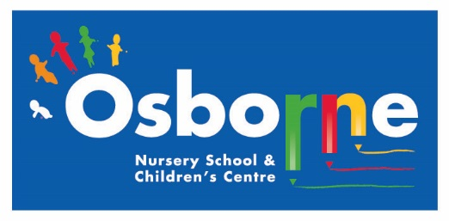**Osborne News**

**April 2017**

www.osbornenurseryschool.co.uk

Nursery News:

On 30th March we successfully passed our Rights Respecting Schools Award assessment. We have now gained our level 1 award. Many thanks to all the governors, parents and carers who talked to our assessor about the things we have been doing around the UNICEF Rights of the Child.

Well done to everyone who have completed all their superhero challenges at home so far!

Dates:

Wednesday 5th April – **Easter Celebration Day** – Join your child for lots of Easter fun activities

Monday 10th – Friday 21st April – **Easter Holidays** – nursery closed

Monday 24th April – **Staff INSET Day** – nursery closed for children

Tuesday 25th April – **Children return to nursery**

Monday 1st May – **May Day Bank Holiday** – nursery closed

Wednesday 3rd May – **Play and Learn with your Child Day** – Keeping Healthy

Wednesday 10th May – **Sutton Park Visit** for all children

Wednesday 17th May – **Keyworker Group Photographs**

Monday 22nd May – **Play and Learn with your Child Day** – Early writing skills **(12.20-3.20pm only)**

Wednesday 24th May – **Animal Antics** Visit to nursery

Friday 26th May – **Play and Learn with your Child Day** – Early writing skills **(8.30-11.30am only)**

29th May – 2nd June – **Half Term** – nursery closed

Image result for easter eggs

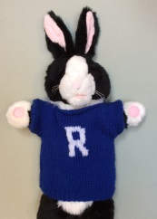



Reception Places for September 2016

Children born between 1st September 2012 and 31st August 2013 will be going to Reception class in a primary school in September 2016. You should receive confirmation of your child’s place on Tuesday 18th April. When you receive this please let your keyworker know. If you do not receive your confirmation please seek advice from Elaine Gilhooly in our school office when you return to nursery.











Easter Celebrations

Join your child for all or part of their session on 5th April as we celebrate Easter with activities such as egg and spoon races, an egg hunt in the garden or make an Easter bonnet together.

Cool Kittens for February were

**Square am Group**

with 91% average attendance

Well Done!





We hope everyone has a good Easter holiday, don’t eat too much chocolate!