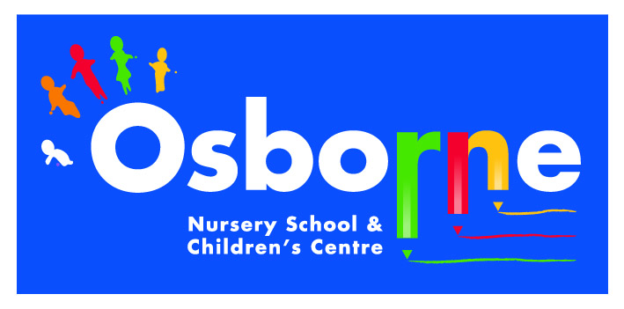**Osborne News**

**February 2017**

www.osbornenurseryschool.co.uk

Nursery News:

Many thanks to all the parents/grandparents who accompanied their children on the library visit.

Please don’t forget to use our school library too. The days for changing books for each group are;-

* Monday: Squares
* Tuesday: Badgers
* Wednesday: Triangles & Squirrels
* Thursday: Circles & Robins

Dates:

Wednesday 15th February – **Play and Learn with your Child Day** – Technology and e-safety**,** join your child for some or all of their session.

20th – 24th February – Half term holiday, nursery closed

Wednesday 1st March – **World Book Day** – children to come to nursery dressed as a favourite character

Wednesday 1st March – **Storytime with Parents & Carers** – am and Badger children 11am, pm, Squirrel & Robin children 3pm

Week beginning 6th March – Individual **Parent /Carer meetings** with keyworkers – book a time with your keyworker:

* Mon 6th Squirrels
* Tue 7th Circles
* Wed 8th Badgers & Robins
* Thurs 9th Squares
* Fri 10th Triangles



World Book Day

Remember to come to nursery dressed as your favourite character on 1st March for World Book Day. We’ll give you a token that you can exchange at book shops for a free book. This year the free pre-school books are great!

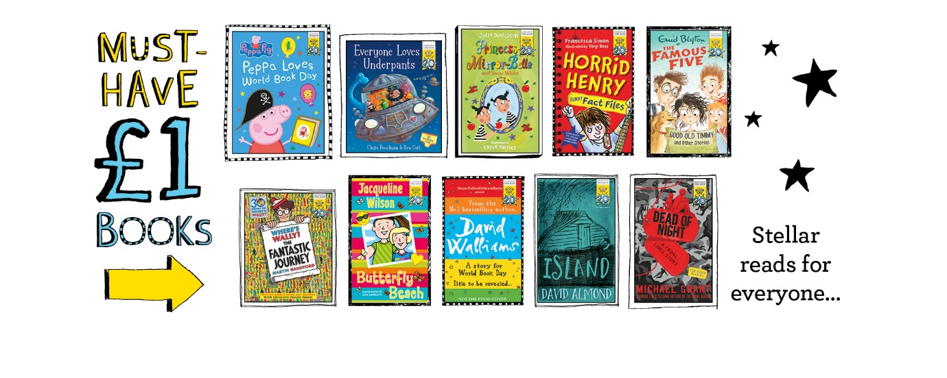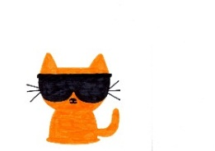

Cool Kittens for January were

**Circles pm Group**

with 90% average attendance

Well done Circles!



Play & Learn with your Child Day

Join your child on 15th February to do lots of activities that use different technologies and build a robot together.

West Midlands Police will also be here to show you how to keep your children safe whilst online.

Writing Names

When children begin writing their

names on the whiteboards at the

beginning of their sessions it is

very important that they do this by themselves. Please don’t hold their hand whilst they write and don’t worry if the letters are not formed correctly at first. Staff will correct their letter formation as they gain in confidence. It’s more important for you to value your child’s attempts at writing at this early stage.

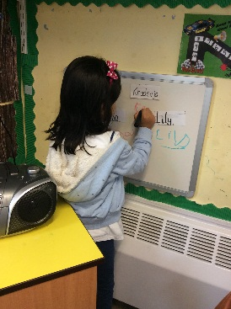

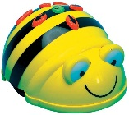

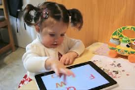

 

As part of our teaching and learning around keeping safe we also need to focus on keeping safe online. Remember you wouldn’t leave your child alone in a park unsupervised so similarly young children shouldn’t be left unsupervised alone on the internet.

Children are only 3 clicks away from inappropriate material- so please use apps such as YouTube with your child even if they are watching recommended videos.

UN Convention on the rights of the child

**Article 17**- you have the right to get information that is important to your well-being from books, computers and other sources. Adults should make sure that the information is not harmful and help you find and understand the information you need.

**Article 24-** you have the right to be safe from harm

**Things your child will be learning at nursery this month and ways you can support them at home.**

Square group and the older Rectangle group children are continuing to work with rhyming words. Some children will be learning letter sounds, hearing and saying initial sounds in words.

When the children learn each letter sound (called a phoneme) it is important they learn what we call ‘pure sounds’ e.g. phoneme for f should be taught as ‘fffff’ not ‘fuh’. Please don’t hesitate to speak to your child’s keyworker if you are unsure or need any advice.

Our new children in the Circle groups are learning how to use and play with our resources, as they explore all of our different learning spaces in nursery. They are also getting to know each other in their group.

Please encourage your child to talk about what he/she has been doing at nursery. Let them show you around nursery during our next play and learn day.

Triangle group children will be encouraged to extend their listening skills and vocabulary. They will play lots of games and engage in role play, acting out stories and nursery rhymes.

At home encourage your child and help develop their listening skills play games which involve listening for a signal, such as ‘Simon says’.