**Osborne News**

**January 2017**

www.osbornenurseryschool.co.uk

Dates:

Wednesday 11th January – **Stranger Danger Talks** from West Midlands Police

Monday 16th January – **Library visits** – Squares (9am & 1pm), Badgers (10.15am) & some Squirrels (2.15pm)

Friday 20th January – **Library visits** – Triangles (9am & 1pm), Robins (2.15pm) and some Squirrels (10.15am)

Friday 27th January – **Chinese New Year Celebration Day** - join your child for some

or all of their session.

Wednesday 15th February – **Play and Learn with your Child Day** – Technology and e-safety**,** join your child for some or all of their session.

20th – 24th February – Half term holiday, nursery closed

Wednesday 1st March – **World Book Day** – children to come to nursery dressed as a favourite character

Nursery News:

A very happy New Year, we hope 2017 will be a good year for you all!

We have had some new children join us this month so a huge welcome to them and their families. Take a look on Tapestry at what your child is doing at nursery and if you have any questions just ask a member of staff.

This month we would like to invite you to join us and your child on a trip to Erdington library where you will have an opportunity to join if you are not already a library member. Libraries are great ways to give your children access to free books and help them on their journey to becoming readers.



http://www.libraryofbirmingham.com/ss/Satellite?blobcol=urldata&blobkey=id&blobtable=MungoBlobs&blobwhere=1318266063164&ssbinary=true







Play & Learn with your Child Day

Join your child on 15th February to do lots of activities that use different technologies and build a robot together.

West Midlands Police will also be here to show you how to keep your children safe whilst online.

Cool Kittens for December were

**Squares am Group**

with 96% average attendance

Well Done!

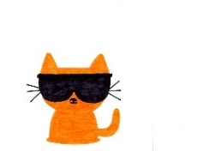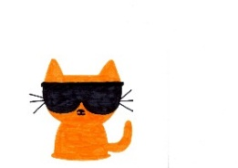

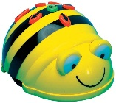

Chinese New Year Celebrations

Join us as we celebrate with our Chinese friends the beginning of the Year of the Rooster with activities such as food tasting, lantern making, dragon dancing and Chinese writing.

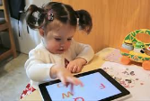



Choking is one of the leading causes of death for young children.

A grape, cherry tomato or blackberry is just the right size to get stuck in your child’s windpipe.

Safeguarding

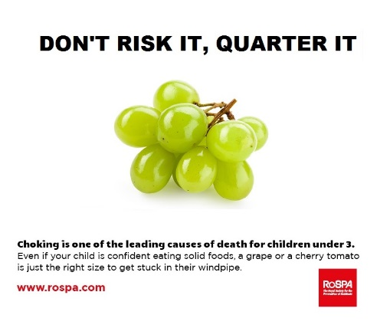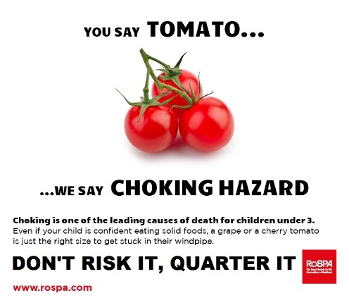

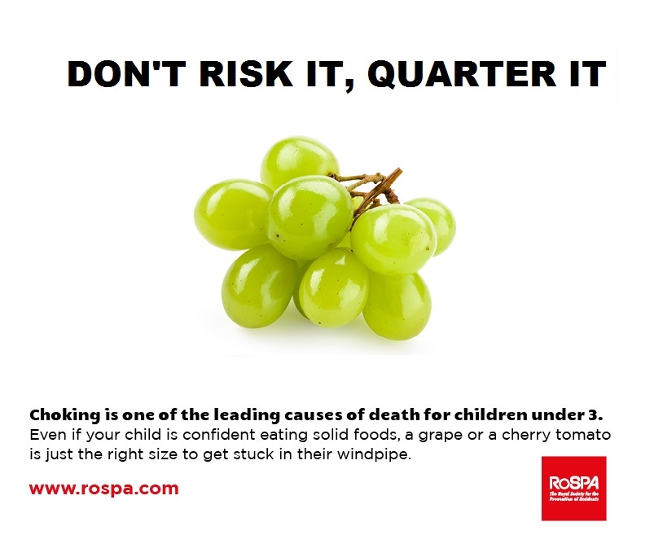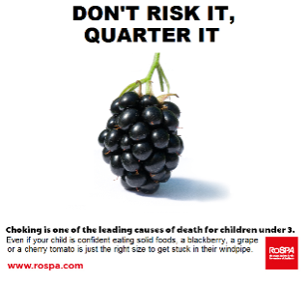

Advice from ROSPA

Winter Weather

Please can you send your child to nursery in layers of clothes so they can put on extra layers (including hats and gloves) when they go outside and take them off when coming back into the building. It is really helpful if you label all items your child may take off with their name, as we often get hats, jumpers and coats that are the same.

In the event of extreme weather (such as heavy snow) please look on our Facebook page

or website for changes to nursery opening hours or listen to radio announcements on

Heart FM, Radio WM or Free Radio





**Things your child will be learning at nursery this month and ways you can support them at home.**

Our youngest children in the circle groups are learning our nursery routines and how to keep themselves safe at nursery.

Please encourage them to take off their own coat when they arrive and hang it on their peg. Then help them to find their name card and place it on the white board, before finding something to play with.

Rectangle group children are going to be brushing their teeth as part of their full-time routine after lunch time during this month. Encourage them to practice brushing their teeth independently at home so that they are able to do this at Nursery also.

Square group will be looking at rhyming words this month. See how many words you and your child can find that rhyme with simple words such as cat and dog or with your names. E.g. cat, mat, sat, fat, hat

You could do this in English or your home language and could include nonsense words. E.g. Sally, rally, pally.

Triangle group children are learning to become more independent with their self- help skills, especially with putting on and fastening their coats before they go outside. At home you could encourage them to practice this.