**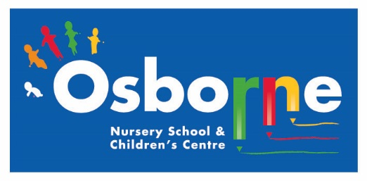Osborne News**

**July 2017**

Dates:

Friday 7th July – **Parent Meetings –** Squares

Monday 10th July – **Ash End Farm Visit**

Tuesday 11th July – **Parent Meetings –** Squirrels (am) & Badgers (pm)

Wednesday 12th July – **Parent Meetings** – Circles & evening parents meeting

Thursday 13th July – **Parent Meetings** – Robins (am) & Squirrels (pm)

Friday 14th July – **Parent Meetings** - Triangles

Friday 21st July – **Robins Leaving Ceremony** 2.30pm

Tuesday 25th July – **Leaving Ceremonies** at 10.30am(am children**)** and 2.30pm (pm, Squirrels & Badgers)

**6th - 8th Sept – Settling sessions for all children who are returning to nursery next academic year.** Individual letters to follow.

Monday 11th Sept – Start date for all returning children

www.osbornenurseryschool.co.uk

Nursery News:

This month we will be doing lots of activities to help those children moving on to Reception. Please keep encouraging your child to talk in English, find letters and numbers around them, dress themselves and use all their independence skills over the summer holidays.

****

Safeguarding

**Ensure your children stay safe online whilst they are on holiday from school.**

www.internetmatters.org is a website dedicated to making sure all parents are only a click away from advice, tips and support about online safety for children. The information is divided into age-appropriate sections to help you talk to your child about the issues and technologies they'll come across as they grow up online. From setting your parental controls to teaching your child how to be a good friend online, you'll find a wealth of information so that you can spend less time researching and more time having fun with your family.



C:\Users\sharone\AppData\Local\Microsoft\Windows\Temporary Internet Files\Content.IE5\9BZ1QB9Z\certificate_icon[1].jpg

****

Ash End House Farm Visit

Please remember to send your child with a raincoat, packed lunch and drink on 10th July for our visit to Ash End House Farm in a back pack they can carry.

Also wear trainers or wellies and if sunny don’t forget the sun cream and a hat.



Leaving Celebration

If your child is leaving us at the end of term we wish them every success for their future! Please join us on 21st /25th July to celebrate their achievements during their time here at Osborne Nursery School and to see them receive their leaving certificate.



Cool Kittens for June were

**Squares am**

with 90% average attendance

SnapMaps: the new app within Snapchat

Last week Snapchat, used regularly by many children and young people, launched a new feature called SnapMaps which allows users to see the exact location of their contacts. Snapchat released the update saying ‘You will be able to see exactly where your Snapchat friends are hanging out and what they are doing there if they have shared it as a story. If you pinch the screen, your location will be shown.’’

Whilst this sounds an exciting enhancement it does allow people to track you and this means that anyone that you are linked to on Snapchat could locate exactly where you are, which building you are in and the exact whereabouts within the building. Whilst this has some use it can also be misused, especially as young people may not be as discerning about which friends they allow access.

There are three possible privacy settings:

* Ghost mode, where only you can see your position;
* My Friends mode, where any contact can see your location; and
* Select Friends mode, just those who you choose can see you

Childnet have produced a fact sheet that gives you more information. It is available at:

<http://www.childnet.com/blog/introducing-snap-maps-the-new-location-sharing-feature-in-snapchat>

**Things your child has been learning at nursery this month and ways you can support them at home.**

Over the last few weeks of term children will be learning about transitions and we will be preparing them for the new changes they will experience after the summer holidays.

Our oldest children will be moving up to their new primary school. Children will need to practice getting changed for P.E. independently. You could put half a smiley face in each of their shoes so that when they are placed together the right way round they form one big happy face to help get the shoes on the right feet. Velcro shoes are easier than laces and much quicker!

Also as the holiday ends prepare your child for the changes in routine they will face and practice them in preparation for primary school e.g. getting up earlier in the mornings to avoid being late for school.

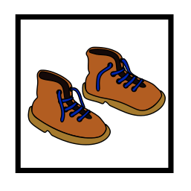    

Our youngest children will be moving groups and may have new children in their groups and a different key worker in September. Talk to your child about these changes and making new friends.