**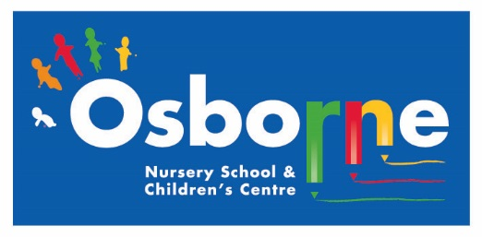Osborne News**

**June 2017**

www.osbornenurseryschool.co.uk

Dates:

Tuesday 13th June – **Transition Meetings** for parents/carers and children with teachers from Osborne and Abbey Primary Schools 4-5pm here at nursery.

Wednesday 14th June – **Play and Learn with**

**your Child Day** – Learning through nature

Wednesday 21st June – **Road Safety Talks**

Wednesday 28th June – **Eid al-Fitr Celebration Day**

Friday 7th July – **Parent Meetings –** Squares

Monday 10th July – **Ash End Farm Visit**

Tuesday 11th July – **Parent Meetings –** Squirrels (am) & Badgers (pm)

Wednesday 12th July – **Parent Meetings** - Circles

Thursday 13th July – **Parent Meetings** – Robins (am) & Squirrels (pm)

Friday 14th July – **Parent Meetings** - Triangles

Friday 21st July – **Robins Leaving Ceremony** 2.30pm

Tuesday 25th July – **Leaving Ceremonies** at 10.30am(am children**)** and 2.30pm (pm, Squirrels & Badgers)

Wednesday 26th July – **Summer Holiday Begins**

Nursery News:

This half term the children will be doing lots of activities outside so could you please send them to nursery in footwear that allows them to run, climb and jump.

Potato Growing Competition

The potato plants are growing well, we’ll let you know the winners next month!





****

DD01366_

Road Safety Sessions

Paul Da Silva from the Road Safety Education Team is coming to give the children an interactive talk about keeping safe around roads. Parents and Carers are very welcome to join us in the meeting room at the times listed below:

9.30-10.20am Squares & Triangles am

10.30-11.20am Circles am & Badgers

12.30-1.20pm Squirrels & Robins

1.30-2.20pm Squares & Triangles pm

2.30-3.20pm Circles pm

****

Play & Learn with your Child Day

Join your child on 14th June to do lots of activities which use the natural environment to help the children learn. Play with the chicks, go minibeast hunting, make a picture with natural objects and visit Forest School.

Please also bring an old container from home (mug, boot, teapot, baked bean can etc) to plant some seeds in with your child.

Eid al-Fitr Celebration Day

Join your child for all or part of their session on 28th June to learn more about how and why our Muslim friends celebrate the end of Ramadan. Taste some different foods

and join in with a variety of activities.



Cool Kittens for May were

**Square am Group**

with 92% average attendance

Well Done!

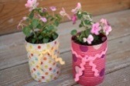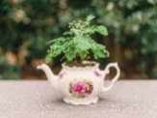

Transition to Primary Schools

All the children going to primary school in September will be offered sessions at their new school. It is very important for them to attend these to help them get ready for the move to their new school. We have children going to 13 different primary schools so please let your keyworker know what dates your child’s visits are.

Over this half term we will also be doing activities in nursery to help prepare our older children for reception class.

**Children going to Osborne Primary and Abbey Catholic Primary Schools**

If your child is going to either Osborne or Abbey please bring them to the meeting with their new teachers here at nursery on 13th June at 4pm. This is a good chance for your child to meet their new staff in an environment they feel comfortable in. It is also a chance for you as parents and carers to talk to the primary staff in an informal environment. This session is useful even if your child has older siblings at the primary school.



**Things your child will be learning at nursery this month and ways you can support them at home.**

All of the children across the groups will be learning about the life cycle of a chicken through our living eggs programme. They will watch carefully what happens to the eggs as they crack, the baby chicks hatch out and grow over time.

They will all have the opportunity to handle a chick!

Come and have a look once they have hatched when you drop off or collect your child so that you can talk together about what you see and share the wonder with them!

 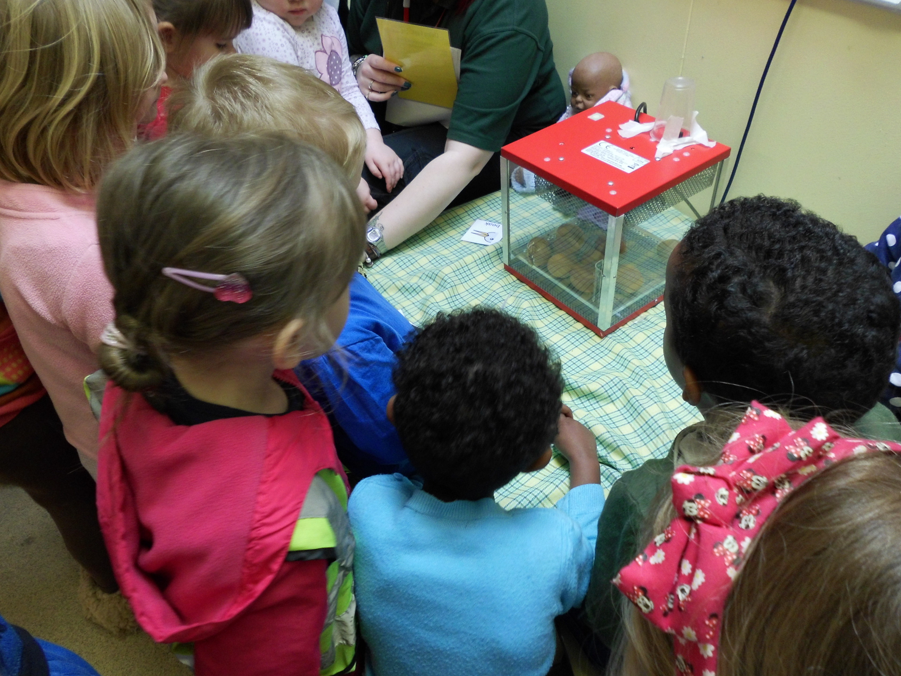 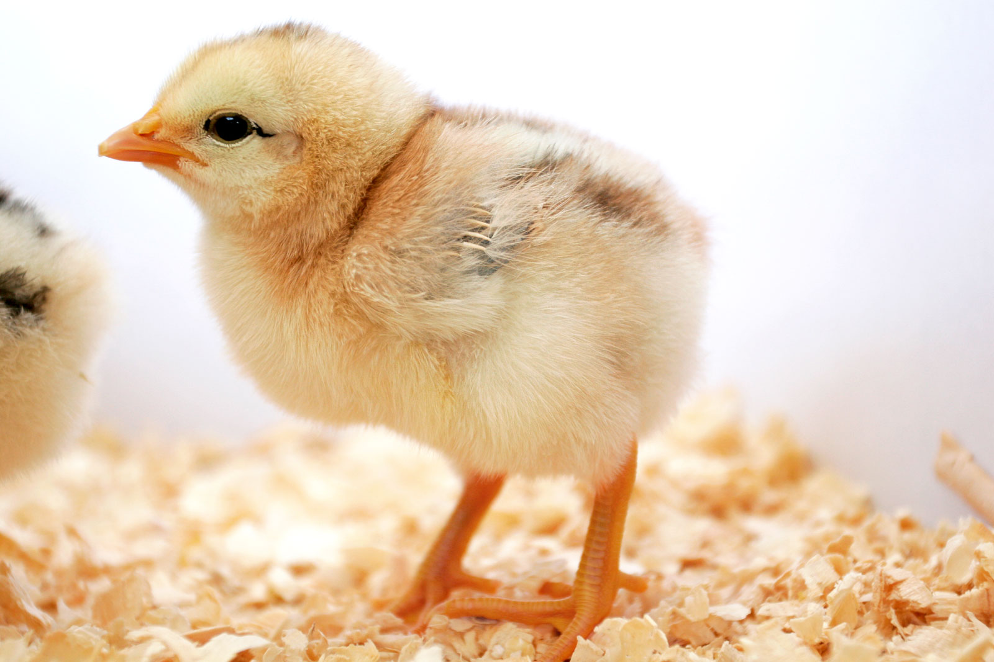

**Things your child will be learning at nursery this month and ways you can support them at home.**