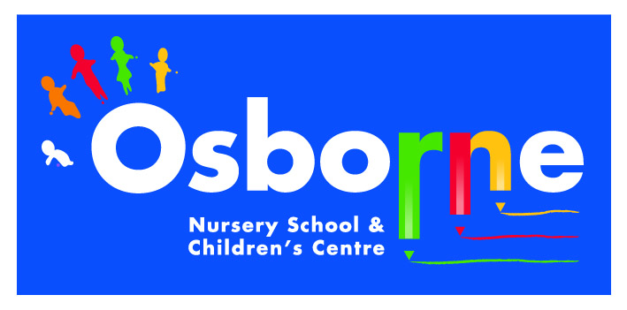**Osborne News**

**March 2017**

www.osbornenurseryschool.co.uk



Nursery News:

Thank you to everyone who came to our technology and e-safety day or completed our questionnaire.

The most popular use for mobile technology by our nursery children is to watch YouTube videos. We were pleased to see that most of you are supervising your children on tablets and mobiles, but those of you who don’t remember on YouTube children are only 3 taps away from inappropriate material.

A safer way is to let them use YouTube Kids. Download the free app or find it at https://kids.youtube.com/

Dates:

Wednesday 1st March – **World Book Day** – children to come to nursery dressed as a favourite character

Wednesday 1st March – **Storytime with Parents & Carers** – am and Badger children 11am, pm, Squirrel & Robin children 3pm

Week beginning 6th March – Individual **Parent /Carer meetings** with keyworkers – book a time with your keyworker:

* Mon 6th Squirrels
* Tue 7th Circles
* Wed 8th Badgers & Robins
* Thurs 9th Squares
* Fri 10th Triangles

14th and 15th March – **Roll Up! Roll Up!** – Theatre production and workshop for all children led by The Play House

Friday 24th March – **Red Nose Day** – wear red to nursery and make a donation

Wednesday 29th March – **Play & Learn with your Child Day** – Maths focus

Wednesday 5th April – **Easter Celebration Day** – Join your child for lots of Easter fun activities

Monday 10th – Friday 21st April – **Easter Holidays** – nursery closed

Monday 24th April – **Staff INSET Day** – nursery closed for children

Tuesday 25th April – **Children return to nursery**

logo

Play & Learn with Your Child

Join your child in nursery for part or all of their session on 29th March for lots of ideas of how to help your child with early maths.

See how your child learns about number and shape through games and fun activities at nursery.



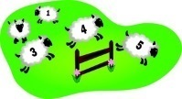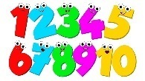

Image result for easter eggs



The Play House Theatre

Roll Up! Roll Up! is an exciting theatre-in-education programme for Nursery and Reception in which the children help Bim to find the confidence to realise his dream of joining the circus as a performer.

The children are involved as supporters, creators and performers working through movement to help Bim to create an act of his own.

Cool Kittens for February were

**Badgers Group**

with 97% average attendance

Great Attendance!





Governor Update

My name is Beata Chukwurah and I am the SEND (Special Educational Needs and

Disabilities) Governor. I have held this position for the past three years. I

regularly meet with Angela Blacker the Deputy Head Teacher and SENCo to

ensure the school is complying with the SEND Code of Practice. I also come into

school to see how the needs of the children with SEND are being met.

In September 2016 Angela obtained the National SENCo Award Qualification. Over the last year the SENCo has introduced Wellcomm screening and Makaton signs and symbols to improve the communication within our nursery. Wellcomm is a speech and language programme that all staff are using with all children to develop their language skills. The use of Makaton provides a visual prompt for those children who need it. They are used daily and displayed within nursery.



**Things your child will be learning at nursery this month and ways you can support them at home.**

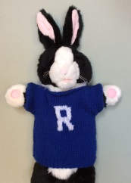

Looking after their group teddy

As part of our embedding children’s rights in our policies and practice we are sending home a teddy to support them to learn about their own rights and how to respect the rights of others and would like you to support us and your child’s learning by looking after their group teddy when he/she comes to visit on Fridays.

Ronnie the rights respecting rabbit sent each group a parcel and a letter asking them to look after teddy. Children have helped meet the **right to a name and identity (Article 7 and 8)** by voting and choosing one together. They will spend the weekend at your home and then come back to nursery on Monday. Here are some of the other rights we would like you and your child to meet:

* **Right to be safe from harm (Article 19)**
* **Right to healthy food, clean water, healthcare (Article 24)**
* **Right to celebrate and join in different activities (Article 30)**
* **Right to relax and play (Article 31)**

You can write, draw or document in the diary what happened whilst visiting your family in whichever way you like. Your child will have time to share these experiences with the group and explain how the rights were met.

You can have a look at what your keyworker has written and how they have related the experiences to the rights of the child.









**