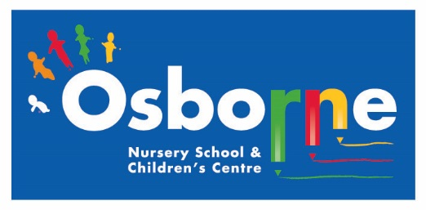**Osborne News**

**May 2017**

www.osbornenurseryschool.co.uk

Nursery News:

We’re all looking forward to ‘going on a bear hunt’ in Sutton Park next Wednesday. Please remember to bring a packed lunch and drink for yourself and your child. Also wear shoes you can walk in comfortably and a rain coat.

Each child will also need to bring along a small soft toy for the teddy bear’s picnic.

Dates:

Monday 1st May – **May Day Bank Holiday** – nursery closed

Wednesday 3rd May – **Play and Learn with your Child Day** – Keeping Healthy

Wednesday 10th May – **Sutton Park Visit** for all children

Wednesday 17th May – **Keyworker Group Photographs**

Monday 22nd May – **Play and Learn with your Child Day** – Early writing skills **(12.20-3.20pm only)**

Wednesday 24th May – **Animal Antics** Visit to nursery

Friday 26th May – **Play and Learn with your Child Day** – Early writing skills **(8.30-11.30am only)**

29th May – 2nd June – **Half Term** – nursery closed



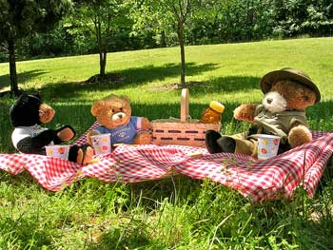







Play & Learn with your Child Days

Keeping Healthy

Join your child on 3rd May to do lots of activities that show how we can keep ourselves healthy. Come and let your child serve you a healthy breakfast or snack in the Jungle Café and challenge each other on our obstacle course.

Early Writing Skills

Join your child on either 22nd or 26th May to see the activities that help your child strengthen the muscles in their hands and arms ready for writing and how our older children learn to write.







Potato growing competition

We have just started our annual potato growing competition. Each group has a pot full of potato plants which they will have to look after this term. We’ll see which group grows the biggest potato and the most potatoes?

**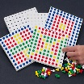****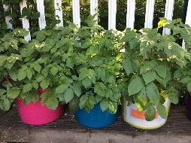**

Animal Antics

Angie from Animal Antics is bringing some of her animals that hatch out of eggs into nursery for us to see and hold.

The children will all have a session

with Angie at some point during

the day.

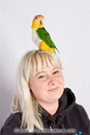

Cool Kittens for April were

**Badgers Group**

with 94% average attendance

Well Done!



Safety in the Sun and Outside

This term the children will be playing and learning outside much more. Please send them to nursery in tops that cover their shoulders and in shoes or trainers that they can run and climb in. Flip flops and open toe sandals are not safe footwear for nursery school. Children will also need a pair of socks in their bag for forest school if they do not come to nursery in socks.

As the weather gets (hopefully!) warmer please ensure you apply suncream to your child before they come to nursery. If your child is in the Rectangle Group please also give a labelled bottle of suncream to your child’s keyworker so it can be reapplied at lunchtime. Children will be encouraged to do this themselves with supervision and assistance from staff.

All children are also now required to wear a sunhat outside. We have purchased

enough hats for the children out of School Fund, however the children can

bring their own hat if they want to, but please remember to put their name in it.





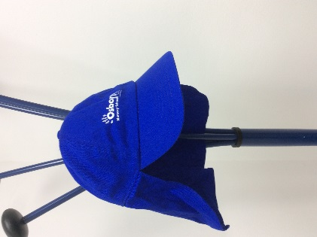

**Things your child will be learning at nursery this month and ways you can support them at home.**

Square group and the Rectangle group children are beginning to learn about life cycles.

Over the next few weeks they will be taking part in planting activities including looking after the potatoes for our competition.

At home you could try growing simple seeds e.g. cress and once grown you could put the cress into a salad or sandwiches and eat them!

In the Circle groups our youngest children are learning how to adapt to new events in nursery, such as being visited by the ‘Animal Lady’ or going on a trip to the park.

You can support them by talking with them about the activities and events that are coming up at nursery. (See diary dates above for events this half term.)

Triangle group will be learning about how different plants grow, looking at the size of seeds and what we need to do to help them grow.

Talk to your child about changes around where you live, in gardens, parks and pathways. What’s growing? How many things can they see? What colour are they?

**Things your child will be learning at nursery this month and ways you can support them at home.**