**Osborne News**

**November 2016**

www.osbornenurseryschool.co.uk

**C:\Users\sharone\AppData\Local\Microsoft\Windows\Temporary Internet Files\Content.IE5\NEZO30YH\MC900363604[1].wmf**

Nursery News:

As the weather turns colder

please ensure your child has a coat

and appropriate outdoor clothes with them each day as they do play in the garden every day, whatever the weather.

Welcome to all the new children and families that have joined us this month. If you want to know anything about our nursery please ask your keyworker.

Most of our new children are

in circle group with Dawn.

Dates:

Wednesday 9th Nov- **Road safety sessions** with Paul D’ Silva

Monday 14th Nov- Badgers & Squirrels parent/carer meetings

Tuesday 15th Nov – Square parent/carer meetings

Wednesday 16th Nov – **Individual Photos** taken

by Academy Photos

Wednesday 16th Nov – Evening parent/carer meetings for all groups 5-6.30pm

Thursday 17th Nov – Circle am & Robins parent/carer meetings

Friday 18th Nov – Triangle parent/carer meetings

Wednesday 23rd November-**Environmental walks**

Wednesday 30th November – **Play and Learn with your Child Day** – families are welcome to join us for all or part of their child’s session

Wednesday 14th December – **Christmas Around the World Celebration Day** – families are welcome to join us for all or part of their child’s session

Thursday 15th December - **Party Day** – all children will have a Christmas party today (regardless of their usual days at nursery)

Friday 16th December – **Christmas holiday begins**

**C:\Users\sharone\AppData\Local\Microsoft\Windows\Temporary Internet Files\Content.IE5\NSVKJDB4\MC900022721[1].wmf**





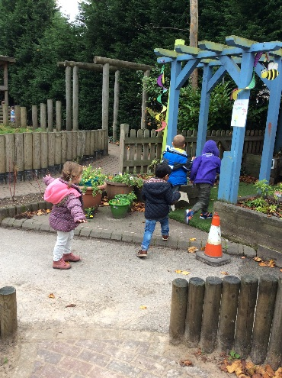





Cool Kittens for October were

**Triangle am Group**

with 92.7% average attendance

Well Done!!



Play & Learn with Your Child Day

The first of these this year in October

was very successful with lots of parents telling us that they found the day informative and enjoyable. The next one on 30th November will have a language focus. Join your child for part or all of their session to do some activities that will help develop your child’s speaking and listening skills.

Road Safety

Parents are welcome to join their child for their interactive road safety session with Paul from Birmingham’s Road Safety Team. Paul’s sessions are usually a lot of fun as well as informative. Ask your keyworker for your child’s session time and join us in the meeting room in the children’s centre.

Safeguarding

If you’re a motorist then you’ll know how difficult it can sometimes be to see pedestrians wearing dark clothes at night or when visibility is poor. Your child will be learning the road safety message **‘Be Safe, Be Seen’** at nursery next week and it’s important that you as a parent or carer help your child to be easily seen near traffic, as well as setting an example to your children by wearing something bright or white too.

**How can my child be seen more easily?**

**1. On dull days your child can wear bright or fluorescent colours**

* Special high-visibility tabards and other clothing can be bought from many retailers
* Fluorescent armbands can also be worn over coats and other clothing
* Bags are also available in bright colours or with high-visibility strips

**2. If walking near traffic at night reflective clothing is needed**

* Reflective clothing reflects light from car and bike headlamps
* Reflective armbands and clothing can be bought for children
* Remember that fluorescent colours do not show up in the dark

Governors

Our Governors are currently working towards The Governor Mark. This is a recognised standard for quality governance in schools. They will be meeting on 28th November (9.30am – 12.30pm) to continue this work. We’ll let you know next month how they get on.

If you would like to know more about being a governor speak to one of our parent governors who both have children in the circle group: Andrew Beata



**Things your child has been learning at nursery recently and ways you can support them at home.**

All groups have been learning about sharing resources and how to take turns during activities with other children. They are learning the code of conduct we follow at nursery:

* To be sensible and helpful
* To be kind and friendly
* To be safe and take care

You can also use this language when talking to your child and encouraging this behaviour at home.