**Osborne News**

**November 2017**

Dates:

Wednesday 1st Nov - Road safety sessions with

Paul D’Silva – Be Safe, Be Seen

Wednesday 8th Nov- Play and Learn with Your Child – join your child for all or part of their nursery session

Monday 13th Nov- Badgers & Squirrels parent/carer meetings

Tuesday 14th Nov – Triangle parent/carer meetings

Wednesday 15th Nov – **Individual Photos** taken

by Academy Photos

Wednesday 15th Nov – Square parent /carer meetings in day and evening parent/carer meetings for **all** groups 5-6.30pm

Thursday 16th Nov – Little Learners parent/carer meetings

Friday 17th Nov – Badgers & Squirrels parent/carer meetings

Wednesday 22nd November - **Environmental walks** – we will be walking around our immediate environment looking for shapes, letters and numbers – parent helpers needed please

Wednesday 29th November – **Nursery Rhyme Dress Up Day** – children & staff to come to nursery dressed up as a nursery rhyme character

www.osbornenurseryschool.co.uk

**C:\Users\sharone\AppData\Local\Microsoft\Windows\Temporary Internet Files\Content.IE5\NEZO30YH\MC900363604[1].wmf**

Nursery News:

As the weather turns colder

please ensure your child has a coat

and appropriate outdoor clothes with them each day as they do play in the garden every day, whatever the weather.

Welcome to all the new children and families that have joined us this month. If you want to know anything about our nursery please ask your keyworker.

**C:\Users\sharone\AppData\Local\Microsoft\Windows\Temporary Internet Files\Content.IE5\NSVKJDB4\MC900022721[1].wmf**





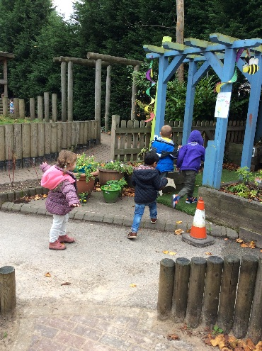





Cool Kittens for October were

**Caterpillars am Group in Little Learners**

with 100% average attendance

and

**Squirrels Group in Explorers**

with 97% average attendance





Play & Learn with Your Child Day

Our first play and learn day next Wednesday will show you how we develop your child’s independence, personal and social skills whilst they are at nursery.

Join them for part or all of their session for lots of fun activities through which your child will learn important skills.

Also meet Ronnie our Rights

Respecting Rabbit at carpet time.

Parent Meetings with Keyworkers

Please book your individual appointment with your keyworker for a parent/carer meeting.

These meetings are a time to discuss your child’s progress in detail and let you know how you can support their learning at home.

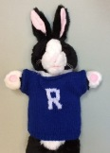

Safeguarding

If you’re a motorist then you’ll know how difficult it can sometimes be to see pedestrians wearing dark clothes at night or when visibility is poor. Your child will be learning the road safety message **‘Be Safe, Be Seen’** at nursery this week and it’s important that you as a parent or carer help your child to be easily seen near traffic, as well as setting an example to your children by wearing something bright or white too.

**How can my child be seen more easily?**

**1. On dull days your child can wear bright or fluorescent colours**

* Special high-visibility tabards and other clothing can be bought from many retailers
* Fluorescent armbands can also be worn over coats and other clothing
* Bags are also available in bright colours or with high-visibility strips

**2. If walking near traffic at night reflective clothing is needed**

* Reflective clothing reflects light from car and bike headlamps
* Reflective armbands and clothing can be bought for children
* Remember that fluorescent colours do not show up in the dark

Governors

One of our parent governors’ term on the governing board ends in January so we’ll be looking for a new parent to be a governor. Nomination forms will be sent out at the end of the month.

If you would like to know more about being a governor speak to one of our existing governors who are parents and both have children in the rectangle group: Andrew or Beata

Alternatively speak to Sharon or Elaine.



Nursery Rhyme Week – 27th Nov-1st Dec

Come dressed as a nursery rhyme character on Wednesday 29th November as part of our nursery rhyme week.

Parents, how many nursery rhymes can you remember? Say them with your child and help develop their understanding of rhyme, an important first step in learning to read.

Explorers Book of the Month

In October children in Explorers did lots of activities around the traditional tale Goldilocks and the Three Bears, such as role playing in the three bears’ cottage and making porridge.

This month they will be focussing on The Gingerbread Man. Ask your child to re-tell you the story, maybe you could act it out together at home.





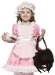

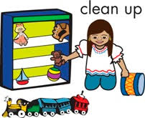****

Little Learners

We are learning how to tidy up and put things away in the correct

place in Little Learners. This is also something you could encourage

your child to help with at home.

We are also enjoying playing with playdough and slime to build our finger and hand muscles ready for writing. We make these ourselves so if you would like the recipe to make them at home ask your key worker.