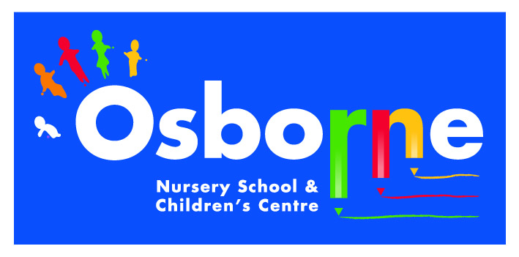**Osborne News**

**October 2016**

www.osbornenurseryschool.co.uk

Dates:

Monday 3rd Oct/Friday 7th Oct – Story time with parents and carers for Robins & Squirrels Group at 3-3.20pm

Wednesday 12th Oct – Play & Learn with your Child Day – families are welcome to join us for all or

part of their child’s session

Wednesday 19th Oct –Autumn walk at Sutton Park on the train

24th– 28th Oct – Half term holiday

Wednesday 2th Nov – Diwali celebration day

Wednesday 9th Nov- Road safety sessions with Paul D’Silva

Monday 14th Nov- Badgers & Squirrels parent/carer meetings

Tuesday 15th Nov – Triangle parent/carer meetings

Thursday 17th Nov – Square parent/carer meetings

Friday 18th Nov – Circle am & Robins parent/carer meetings

Nursery News:

All the children are now settled in at nursery. They are busy learning

how to play with each other,

take turns, share the toys and

ask for help when needed.

Please encourage your child to hang up their own coat and bag on their peg when they arrive at nursery as this

supports the independence

skills they are learning.

The children have started Forest School sessions on either a Tuesday or Thursday. Please ensure they have a waterproof coat with them on these days and as the weather turns colder a warm hat and gloves or mittens.

**C:\Users\sharone\AppData\Local\Microsoft\Windows\Temporary Internet Files\Content.IE5\NEZO30YH\MC900436041[1].wmf**

**C:\Users\sharone\AppData\Local\Microsoft\Windows\Temporary Internet Files\Content.IE5\NEZO30YH\MC900088884[1].wmf**

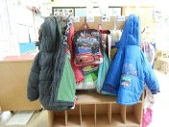

Cool Kitten Group

for September was

**Triangle am Group**

with 99% average attendance

Well Done!



Request for parents/ carers

Can you please encourage your children to leave their own toys at home and not bring them to Nursery. Key workers will have to put them away when it is time to sit down and they can cause disruption at learning group times. We encourage ‘empty hands’ to help concentration.

Tapestry

Thank you to parents and carers who have been regularly looking at their child’s learning journal on Tapestry. Well done to those parents who are leaving comments and uploading their own observations!

If you need any help doing any of the above please ask a member of staff.



**C:\Users\sharone\AppData\Local\Microsoft\Windows\Temporary Internet Files\Content.IE5\NSVKJDB4\MC900434383[2].wmf**

Please remember to telephone us on 675 1123

if your child is too ill to be at nursery.

**Rights Respecting Schools Award (RRSA)**

We have achieved our recognition of commitment to the Rights Respecting Schools Award (RRSA) and as part of this award we need to work with the children as well as with you to raise awareness about the convention.

Our returning children have already met **Ronnie the rights respecting rabbit** but all new children will also be introduced to him. He will help them learn about their rights through different activities.

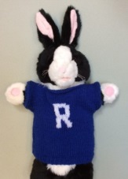



Join us at the **Play & learn session on Wed 12th Oct** to find out more about this, also look out for our Ronnie challenges you can do with your child and receive a Ronnie sticker when completed!

**Things your child has been learning at nursery recently and ways you can support them at home.**

**Circle Group**

Can you help the children with their independence skills – doing their coat up, putting on their shoes

Also encourage your child to talk about their nursery experiences

**Rectangle Group**

We are becoming more independent at lunchtimes and are enjoying sitting with our friends when we eat.

You can support your child at home by encouraging them to feed themselves using a knife and fork.

**Triangle Group**

We have been learning about the different rooms at nursery and how to play safely and sensibly with the activities in them.

Encourage your child to tell you about their day at nursery and where they have played.

**Square Group**

We have been learning about how to do things for ourselves more confidently e.g. dressing, getting changed for Forest School

Please encourage your children to dress themselves at home.