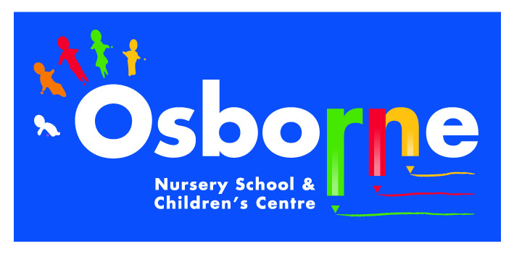

Special Educational Needs and Disabilities (SEND) Policy

October 2014

Inclusion Statement

“Every child has a fundamental right to education and must be given the opportunity to achieve and maintain acceptable levels of learning. Every child has unique characteristics, interests, abilities and learning needs. Education systems should be designed and educational programmes implemented to take into account the wide diversity of these characteristics and needs. Those with special educational needs must have access to mainstream schools, which should accommodate them with a child centred pedagogy capable of meeting those needs. Mainstream schools with this inclusive orientation are the most effective means of combating discriminatory attitudes, creating welcoming communities, building an inclusive society and achieving education for all. Moreover, they provide an effective education for the majority of children (without special needs) and improving the efficiency and ultimately the cost effectiveness of the entire education system.”
(The Salamanca Statement adopted by UNESCO, July 1994, quoted in Disability Equality in Education, Feb. 2002)

Osborne Nursery School is committed to providing inclusive Nursery education. We value diversity and seek to support each child, their family and carers and adults in the Nursery community to reach their full potential. We support the Government’s “Early Support” principles as the mechanism for achieving better coordinated family focused services for very young disabled children and their families, as detailed in the Every Child Matters Framework. (DfES 2003)

Following guidelines outlined in the Children and Families Act 2014, Osborne Nursery School will implement the following principles and policies.

All pupils will be admitted to school following the published admission criteria.

Pupils will not be discriminated against on the grounds of SEN/Disability.

Children with special educational needs or disabilities (SEN/Disabilities) will have their needs met.

Children who have SEN/Disabilities will be fully included in the school community.

The views of children will be sought and taken into account.

Parental partnership is the key to children achieving their full potential therefore parents/cares will play a vital role in supporting their child’s education and will be valued partners in the education process.

Parents/carers will be included in discussions about their child and early identification of SEN/Disabilities. Parents/carers will be actively encouraged to participate in the teaching, learning, assessment and evaluation process.

Children with SEN /Disabilities will be offered access to a broad, balanced and relevant curriculum for the Foundation stage.

The school will provide inclusive teaching and learning approaches that are beneficial for all children.

The school will provide a flexible approach to transition into nursery that is beneficial for all children. Transition to primary school will be ‘tailor made’ to meet individual children’s needs where appropriate.

The school will provide environmental access and relevant printed information for pupils/and adults.

Pupils with SEN/Disabilities and their families will have information about and access to support services and other agencies. The school will work in partnership with other agencies.

The school will provide information about and follow the Special Educational Needs and Disability Code of Practice: 0 to 25 years (September 2014) in order to support pupils with SEN/Disabilities and their families.

The school website contains details of our policy for special educational needs and the special educational needs information report including the arrangements made for children in our school with special educational needs.

Definitions of Special Educational Needs

Has a significantly greater difficulty in learning than the majority of children the same age.
Has a disability which prevents or hinders them from making use of educational facilities of a kind generally provided for children of the same age in the school within the area of the Local Authority.
Are under compulsory school age and fall within the definitions above or would do so if special educational provision was not made for them.

Definition of Disability

A person has a disability if they have a physical or mental impairment which has a substantial and long term affect on their ability to carry out normal day to day activities including:-
Mobility
Physical coordination
Manual dexterity
Continence
Speech, hearing or sight
Memory and ability to learn, concentrate or understand.
Difficulties with perceptions of risk or physical danger.

Parent Partnership

This school will promote parent partnership in the following ways:-

Parents will be actively informed, involved, supported and empowered
through the following ways
On registration for a Nursery place parents have a responsibility to communicate any concerns they have about their child’s learning or provision needed.
By providing information about the school’s inclusive approaches at induction meetings, through the school website and policies’ through initial discussion meeting with key-worker and where appropriate through home visits.
By encouraging them through ideas, practical activities, workshops and meetings with special education professionals to fulfil their role in their child’s education.
By exchanging information, advice and support during decision making and assessment processes including the ‘All About Me’ profile completed at the initial discussion meeting, parent consultations and during multi-agency meetings.
By providing a welcoming and user friendly environment that encourages parents to make their views known about their child’s needs and provision needed.
By providing parents/carers advice, support and information about the SEN Code of Practice.
Implementation of the Early Support Programme where parents feel they can benefit from it.
By active involvement at progress reviews through to the development of Education, Health and Care (EHC) plans and twelve monthly reviews of EHC plans where appropriate.
By regularly reviewing as part of the school monitoring and evaluation process to ensure there are no barriers to parent participation

Pupil Participation

"The views of the child should be give due weight according to the age, maturity and capability of the child" Articles 12/13 The United Nations Convention on the Rights of the Child.
Osborne Nursery School considers that children have a unique view of their needs and should feel valued and listened to.
The children will be encouraged to make choices and share their wishes and feelings with staff, carers and their family.
The children will be encouraged to share their choices, feelings and wishes through PSED and well being group times.
The staff will encourage the children to be focused in their actions and thinking, to problem solve and to celebrate their success.
Some children will experience communication difficulties and a range of strategies will be used to support them to participate through art, audio, video and the use of sign, gesture or symbol communication.
The staff will report pupils’ views, reactions and responses in reports, during reviews, through EHC plans and annual reviews.

Identification, Assessment, Provision

The school takes a graduated approach to the assessment of pupils with SEN /Disabilities.
The school will take action if the child's rate of progress is cause for concern and it will be necessary to take additional or different action.
Action will be taken for the following reasons,
The pupil continues to respond, develop or work at a level significantly below the level expected for the child of a similar age.
The pupil makes little or no progress with targeted support.
The pupil has significant or persistent difficulties in the following areas of development: -
Communication and interaction
Cognition and learning
Social, mental and emotional health
Sensory / physical
We will ensure that all staff are able to identify and provide for those children with special educational needs, allowing them to join in all school activities together with children who do not have special educational needs.

Assessment and Provision

Pupils are assessed using the following assessment tools and approaches on entry to the school:-
- ‘All About Me’ assessment completed by staff and parents during initial discussion meeting.
- Observations of children on entry to the setting and PSED group times.
- Initial Assessment completed by the staff on entry after a short settling in period.
- Ongoing observation and assessment documented in Tapestry Learning Journals and Individual Progress Tracker Sheets.

After initial discussions with the SENCO, the child’s keyworker will be responsible for working with the child on a daily basis and ensuring delivery of any individualised programme in the classroom. Parents will continue to be consulted and kept informed of the action taken to help their child, and of the outcome of any action. Parents will be invited to meet at least termly with the keyworker and SENCO to discuss individual learning targets and progress.

The SENCO will support further assessment of the child where necessary, assisting in planning for their future needs in discussion with colleagues and parents.

Education, Health and Care Plans

The Head teacher or parents can request an education, health and care plan. Parents will be provided with individual comprehensive support throughout the assessment process.

Education, health and care plans will be required for the following reasons:
The pupil has severe or complex needs which will need support through much of school life.
Where specialist early years intervention cannot be provided in the setting.

Pupils who have an educational health and care plan will have it reviewed every twelve months.

Teaching and Learning Strategies

Pupils who need support that is additional or different will be provided for in the following ways:-
Individual 1-1 support
Small group support
Planned opportunities to generalise new skills and knowledge
Differentiated teaching methods detailed in nursery and provision planning
Additional staffing where required when funding allows through the ISEY assessment process
Access to the physical environment and the Early Years Foundation Stage Curriculum through the use of additional or adapted resources
By breaking down the skills and knowledge into smaller attainable steps to avoid failure and to promote success.
By the use of multi-sensory teaching approaches.
By the use of augmentative methods of communication such as signs and symbols
Through detailed observation and by maximising the learning pathways using the child's preferred style of learning.
By working in practical partnership with parents and other agencies
By supporting pre-entry and nursery pupils through dialogue with outside agencies as appropriate.
Where appropriate providing a home visit to share information
By providing resources that provide positive images and are age and stage appropriate.

The Role of the Special Needs Coordinator (SENCO)

The nursery school SENCO is a teacher who is part of the Senior Management Team, currently the Acting Head Teacher, Sharon Eeles

The SENCO will have the following responsibilities:-

Overseeing the day-to-day operation of the school’s SEN policy.
Co-ordinating provision for children with SEN.
Advising and supporingt practitioners in the setting.
Ensure and facilitate liaison between parents and professionals.
Ensure the relevant background information about children with SEN/Disabilities is collected, recorded and updated.
Ensure provision plans are in place and reviewed.
Take a lead role in the further assessments of the child's strengths and needs.
Complete relevant reports and attend meetings.
Provide INSET training for staff.
Be aware of and provide information about and access a wide range of
other agencies/services.

The Role of the named SEND Governor

The named governor for children with SEND is currently Beata Chukwurah

This governor will have the following responsibilities:
- To help raise awareness of SEN issues at governing body meetings
- To ensure governors know how the school identifies children with SEN
- To provide up-to-date information on the school's SEN provision
- To take part in the review of the school’s policy on provision for pupils with SEN
- To ensure that parents have confidence in this provision

Working with Other Agencies

The school works closely in partnership with a wide range of other services and agencies. Such partnerships are valued by staff and are used extensively to support and empower pupils and their families and carers.
The school has partnerships with:-
LA services such as Educational Psychologists, Specialist Support Service, Outreach Services, and Parent Partnership Service.
Health services such as Community Paediatricians, Speech and Language Therapists, Occupational Therapists, Physiotherapists, CDC, Dr, Health Visitors.
Social Care and Health services.
Voluntary sector services such as KIDS, Portage Services, and Specific support groups.

Primary Transfer

The school has links with a wide range of Primary schools and Special Schools in the Erdington Community and beyond.

Staff and the SENCO liaise with the Primary schools prior to pupil transfer.
All consultations and record transfers are undertaken with parental consent.
Parents are given information about appropriate Primary schools and for pupils with a statement the LA will provide further information about a range of schools including independent or non maintained special schools.

The school offers transition meetings in the summer term with primary school staff, parents, child and staff to facilitate transition to primary school. Where appropriate parents and staff will visit the receiving primary school and parents, child and staff may visit the receiving primary school.
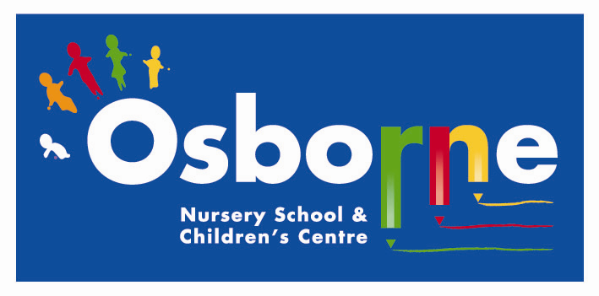

SPECIAL EDUCATIONAL NEEDS AND DISABILITIES (SEND) POLICY

This policy will be reviewed every three years and whenever significant changes to the systems and arrangements take place.

Policy agreed by:-

Signed: …………………………… Date : October 2014
Chair of Governors

Next Review Date: OCTOBER 2017

