Walking and Talking With Your Child

Why Walk & Talk?
By walking and talking with young children they become immersed in language. There is so much to look at and talk about when you are out and about in your local community. Walking and talking is a simple, free activity that promotes healthy living and good communication skills. As parents you can help your child and become more involved in their learning.

How?
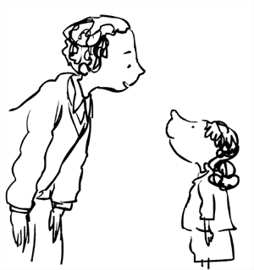
There are three ‘Top Tips for Talking’ with your child(ren).

1. Get down to your child’s level

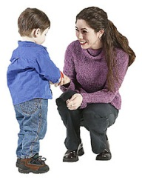
Sit at the same level as your child or crouch down when you are talking together. Being face to face shows you are interested in what your child wants to say. Being face to face also helps your child to see your mouth
and how you say words

2. Talk about the things you see and do
Point out things that you see or do in daily life and describe them for your child. This will help your child to learn new words and how to make sentences. For example, “Wow, you are swinging very high”, “Mummy is pushing the buggy” & “Look it’s raining outside”.

3. Listen and add words
Listen carefully to what your child is trying to tell you and show you. Repeat what your child said to show you understood. You can also add in some extra words to expand on what your child said. For example, if your child says “Big apple” you can say “Yes, a big red apple”.

Where?
You can walk and talk with us each term as we go out from nursery school on trips such as:
- Our environment walk around the block by nursery
- Walking to the library
- Going to Sutton Park on the train

You can also walk and talk…
- on the way to and from school
- in the park
- in the supermarket
- Anywhere!!!!
Please remember to walk safely with your child and … if you are on your mobile phone your child cannot talk to you.

