**Osborne News**

** April 2018**

Dates:

Wednesday 18th Apr – **Animal Antics** – All the children will have a visit from some animals

Wednesday 25th Apr – **Play & Learn with your Child Day** – Being Healthy focus

Thursday 3rd May – Little Learners trip to **Sutton Park by train**

Monday 7th May – **May Day Bank Holiday** – nursery closed

Tuesday 8th May – **Some special eggs arrive at nursery**

Wednesday 16th May – **Play & Learn with your Child Day** – Outdoor learning focus

28th May – 1st June – **Nursery closed for half term holiday**

www.osbornenurseryschool.co.uk

Nursery News:

Safaa our class teacher left at the end of last term. She would like to express her thanks and appreciation for all the kind leaving words, cards and gifts she received.

We would like to welcome Gordon to our team who will be our teacher this term in the afternoon and Liz (from Little Learners) who is moving into Explorers to be our morning teacher.



Play & Learn with Your Child

Keeping Healthy

Join your child on 25th April to do lots of activities that show how we can keep ourselves healthy. Come and let your child serve you a healthy breakfast or snack in the Jungle Café and challenge each other on our obstacle course.

Cool Kittens for March were

**Tadpoles am Group in Little Learners**

with 82% average attendance

and

**Squirrels Group in Explorers**

with 89% average attendance





Little Learners

Little Learners will be ‘going on a bear hunt’ in Sutton Park on 3rd May. Please remember to bring a packed lunch and drink for yourself and your child. Also wear shoes you can walk in comfortably and a rain coat.

Each child will also need to bring along a small soft toy for the teddy bear’s picnic.

Reception Places for September 2018

Children born between 1st September 2013 and 31st August 2014 will be going to Reception class in a primary school in September 2018. You should receive confirmation of your child’s place on Monday 16th April. When you receive this please let your keyworker know. If you do not receive your confirmation please seek advice from Elaine Gilhooly in our school office.

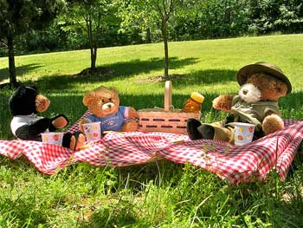

Governor Update

Our two parent governors, Claire & Emma, are organising two parent and governor coffee, cake & chat sessions. Please drop in to one of them to meet our governors and let them know what you think of our nursery school. The sessions are being held on:

at 10.30am and 2.30pm

Thank you to everyone who has donated unwanted and old shoes to our Shoe Share appeal. So far we have collected 122 pairs of shoes. We are going to carry on collecting shoes for another month so if you’ve still got some unwanted shoes at home please bring them in and give them to your keyworker.



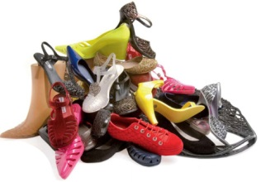

Explorers Book of the Month

In April the children in Explorers will be doing lots of

activities around the traditional tale

Little Learners

We have been learning about colour in Little Learners