**Osborne News**

**February 2018**

www.osbornenurseryschool.co.uk

Nursery News:

Many thanks to all the parents/grandparents who accompanied their children on the library visit.

Please don’t forget to use our school library too. We have recently altered some of the days for changing books, these are now;-

* Monday: Squares & Little Learners
* Tuesday: Badgers & Squirrels
* Wednesday: Circles
* Thursday: Badgers & Squirrels
* Friday: Triangles

Dates:

Friday 2nd Feb – **Little Learners visit to Erdington Fire Station**

Wednesday 7th Feb – **Play and Learn with your Child Day** – Technology and e-safety**,** join your child for some or all of their session.

Friday 16th Feb – **Chinese / Lunar New Year Celebration Day**, join your child for some or all of their session.

19th – 23rd February – Half term holiday, nursery closed

Tues 27th Feb & Thur 1st Mar – **By the Riverbank** – Explorers will all have a theatre performance and workshop from the Play House Theatre.

Thursday 1st March – **World Book Day** – Explorers and Little Learners to come to nursery dressed as a book or film character.

Week beginning 5th March – Individual **Parent /Carer meetings** with keyworkers – book a time with your keyworker:

* Mon 6th Squirrels
* Tue 7th Circles
* Wed 8th Badgers & Robins
* Thurs 9th Squares
* Fri 10th Triangles



Image result for lunar new year 2018

World Book Day

Remember to come to nursery dressed as your favourite character on 1st March for World Book Day. We’ll give you a token that you can exchange at book shops for a free book. These are the free pre-school books you can get with your token:



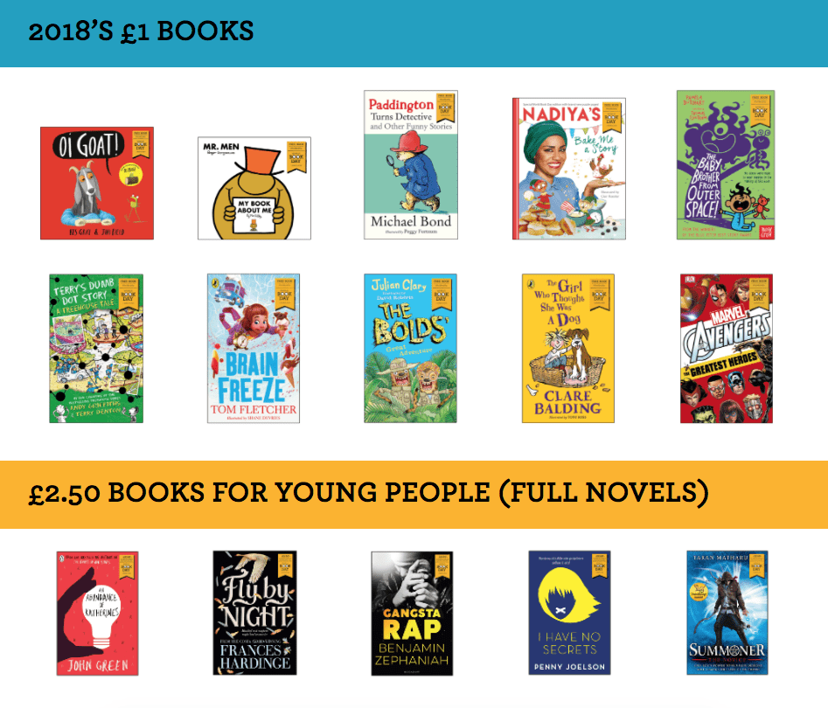

Chinese / Lunar New Year Celebrations

Join us on 16th February as we celebrate with our friends who celebrate the Chinese and Lunar New Year. We will be celebrating the beginning of the Year of the Dog with activities such as food tasting, lantern making, dragon dancing and Chinese writing.

Play & Learn with your Child Day

Join your child on 7th February to do lots of activities that use different technologies and build a robot together.

West Midlands Police will also be here from 9.30 to 10.30am to show you how to keep your children safe whilst online.





Cool Kittens for January were

**Tadpoles am Group in Little Learners**

with 92% average attendance

and

**Squirrels Group in Explorers**

with 91% average attendance

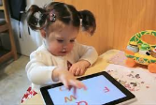



As part of our teaching and learning around keeping safe we also need to focus on keeping safe online. Remember you wouldn’t leave your child alone in a park unsupervised so similarly young children shouldn’t be left unsupervised alone on the internet.

Children are only 3 clicks away from inappropriate material- so please use apps such as YouTube Kids with your child even if they are watching recommended videos.

UN Convention on the rights of the child

**Article 17**- you have the right to get information that is important to your well-being from books, computers and other sources. Adults should make sure that the information is not harmful and help you find and understand the information you need.

**Article 24-** you have the right to be safe from harm



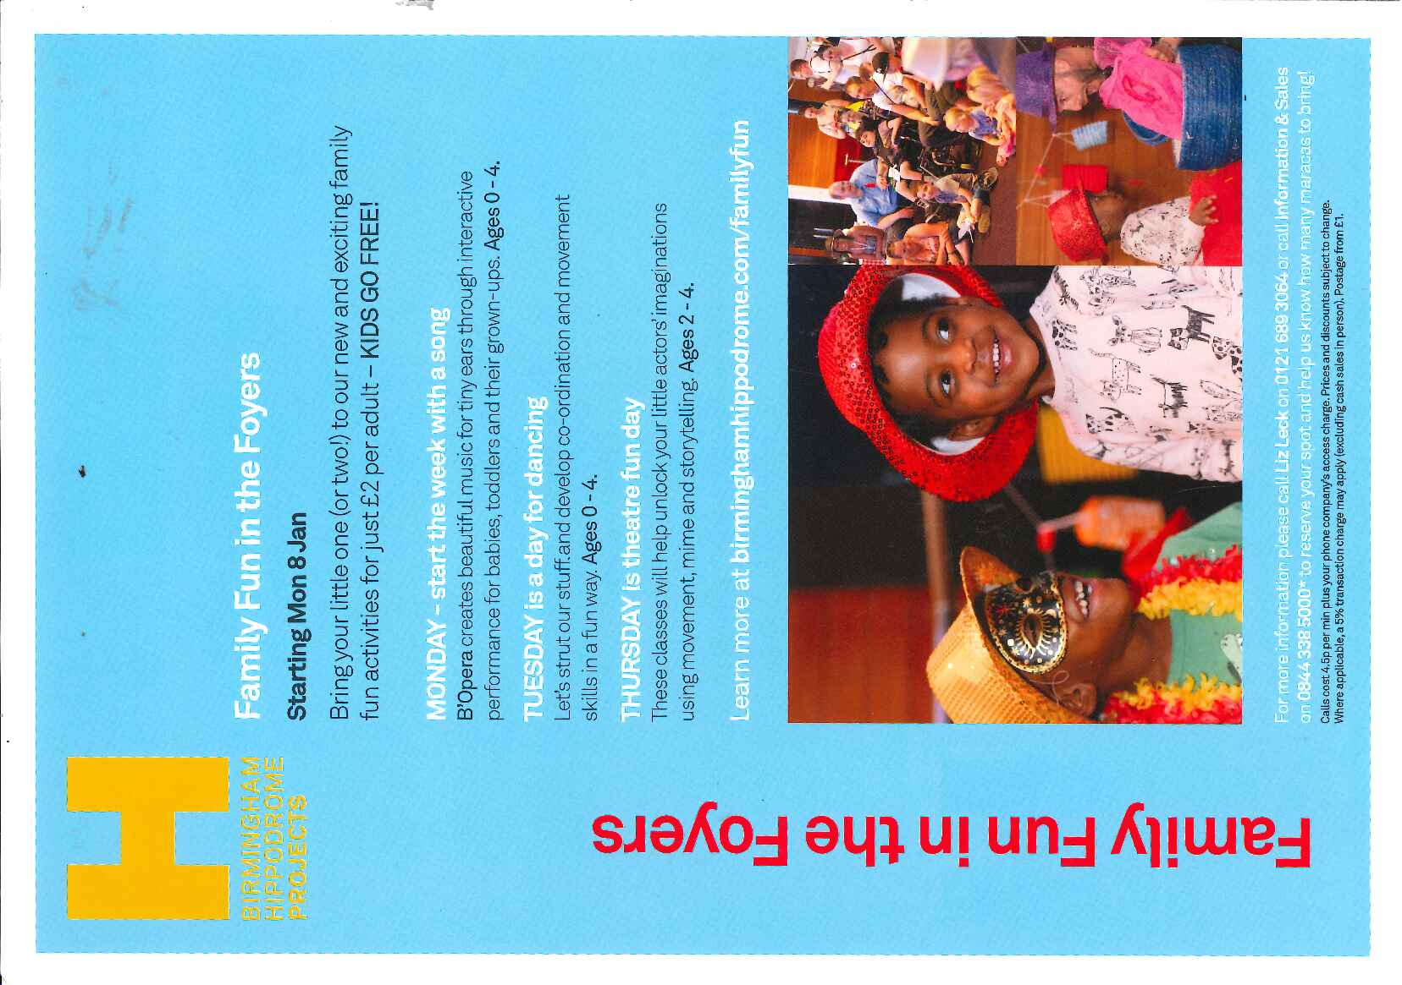

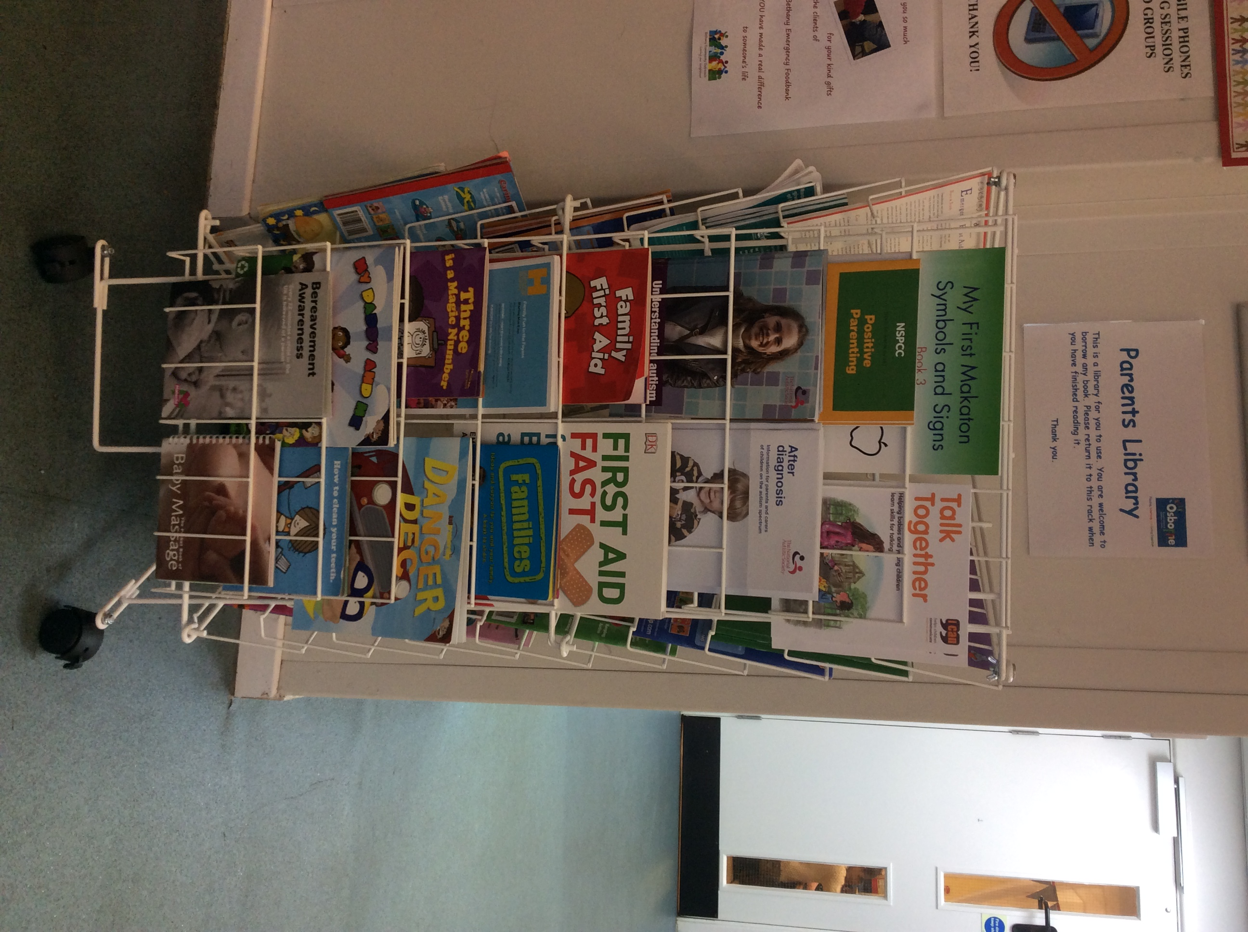

Parents Library

In our school reception we now have a parent/carer trust library. Please come and have a look and borrow any books you like. We just ask that you return them to the stand when you’ve read them so that other parents can borrow them too.

Birmingham Hippodrome have some early years activities you might be interested in.

Explorers Book of the Month

In February the children in Explorers will be doing lots of activities around the traditional tale The 3 Little Pigs. They will be exploring different building materials and doing lots of huffing and puffing as they pretend to be the wolf blowing the pigs’ houses down!



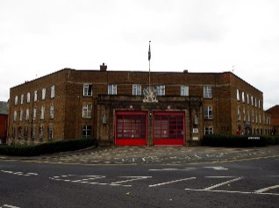

Little Learners

Welcome to all our new children in Little Learners, we are enjoying getting to know our new friends, they are settling in really well.

Please can you all remember to check your child’s folder in the rack by the coat pegs each day for messages and letters.

We’re looking forward to our visit on Friday to Erdington Fire Station, thank you to all the parents and carers who have already returned their letter to say they can help.