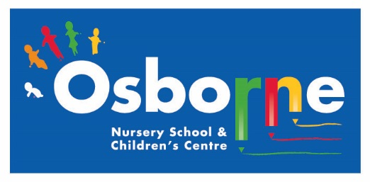**Osborne News**

**March 2018**

www.osbornenurseryschool.co.uk

Dates:

Week beginning 5th Mar – Individual **Parent /Carer meetings** with keyworkers – book a time with your keyworker:

* Mon 5th Squirrels & Badgers
* Tue 6th Triangles & Circles
* Wed 7th Squares
* Thurs 8th Caterpillars & Tadpoles
* Fri 9th Squirrels & Badgers

Wednesday 14th Mar – **Animal Antics** – All the children will have a visit from some animals

Wednesday 21st Mar – **Play & Learn with your Child Day** – Maths focus (Explorers)

Monday 26th Mar – **New Parents’ Induction Meeting**

Wednesday 28th Mar – **Easter Celebration Day** – Join your child for lots of Easter fun activities

Friday 30th March – Friday 13th April – **Easter Holidays** – nursery closed

Monday 16th Apr – **Staff INSET Day** – nursery closed for children

Tuesday 17th Apr – **Children return to nursery**

Nursery News:

It was great to see so many children dressed up for World Book day. Don’t forget to get your free book with your book token.

Explorers had a great theatre workshop with Juliet from the Play House last week. Ask your child how they helped Ruby the Ranger find Portly the baby otter who was missing from home. They will be doing some more follow up activities this week.



We hope everyone has a good Easter holiday, don’t eat too much chocolate!

Play & Learn with Your Child

Join your child in nursery for part or all of their session on 21st March for lots of ideas of how to help your child with early maths.

See how your child learns about numbers and shapes through games and fun activities at nursery.

Image result for easter eggs

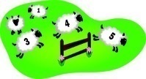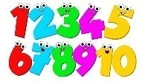

Cool Kittens for February were

**Tadpoles am Group in Little Learners**

with 82% average attendance

and

**Squirrels Group in Explorers**

with 89% average attendance



Easter Celebrations

Join your child for all or part of their session on 28th March as we celebrate Easter with activities such as egg and spoon races, an egg hunt in the garden or make an Easter bonnet together.

Little Learners Outdoor Area

Please can parents and carers ensure that your children respect the Little Learners outdoor area when you walk through it on your way into nursery. We have had a number of the activities damaged by older children at these times.

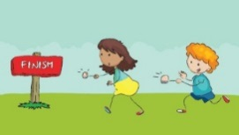



Animal Antics

On 14th March Angie from Animal Antics is bringing lots of her animals into

nursery for the children to look at, stroke and hold. Children in both Explorers

and Little Learners will have a session with Angie at some time during the day.

Look out for lots of photos on Tapestry after their session.

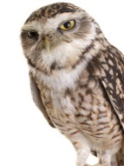

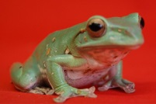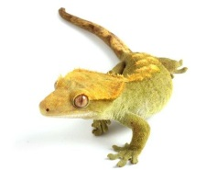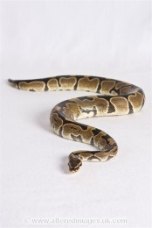

ShoeShare helps children around the world access their right to education and is a campaign in partnership with the Rights Respecting Schools Award and Clarks.

The ShoeShare campaign collects old or unwanted shoes. These old or unwanted shoes are then sent for re-use. For every tonne of shoes collected, a donation is made to Unicef which goes towards education programmes around the world.

Please help us in our ShoeShare by bringing any unwanted adult or children’s shoes into nursery. Our fulltime Squirrels are running our ShoeShare, so if you have any questions please ask them.



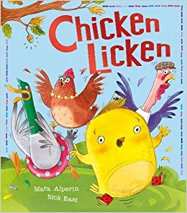

Explorers Book of the Month

In February the children in Explorers will be doing lots of

activities around the traditional tale Chicken Licken. They will

be looking at lots of rhyming pairs like the character names in

the story – Goosey Loosey, Ducky Lucky, Henny Penny.

Try and make nonsense rhymes using names in your family with your child. Here’s some for our nursery staff – Sharon Laron, Sarah Parah, Safaa Cafaa, Dawn Prawn, Denise Menise, Karen Taren

Little Learners

We have been practising to do things for ourselves. Things like putting on our own coats, feeding ourselves with a spoon and asking to go to the toilet. Please encourage your child to do these at home too.

Also please encourage your child to ask for things they want using words not gestures. This will support what we are doing at nursery and help to develop their language skills.