**Osborne News**

** May 2018**

www.osbornenurseryschool.co.uk

Nursery News:

This term the children will be doing lots of activities outside so could you please send them to nursery in footwear that allows them to run, climb and jump.

Strappy sandles and flip-flops are not suitable for nursery and can be dangerous.

Dates:

Thursday 3rd May – Little Learners trip to **Sutton Park by train**

Monday 7th May – **May Day Bank Holiday** – nursery closed

Tuesday 8th May – **Some special eggs arrive at nursery**

Wednesday 16th May – **Play & Learn with your Child Day** – Outdoor learning focus

28th May – 1st June – **Nursery closed for half term holiday**

Wednesday 27th June – Explorers trip to **Hatton Country World** – Outdoor learning focus



Play & Learn with Your Child

Join your child on 16th May to do lots of activities which use the natural environment to help the children learn. Play with the chicks, go minibeast hunting, make a picture with natural objects and visit Forest School.

Please also bring an old container from home (mug, boot, teapot, baked bean can etc) to plant some seeds in with your child.

Cool Kittens for April were

**Tadpoles am Group in Little Learners**

with 95% average attendance

and

**Triangles am Group in Explorers**

with 98% average attendance

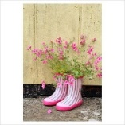

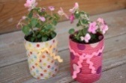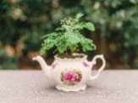



Cake & Chat with our Governors

Our two parent governors, Claire & Emma, are organising two parent and governor cake & chat sessions. Please drop in to one of them to meet our governors and let them know what you think of our nursery school. The sessions are being held on:

Thursday 7th June

at 10.30am and 12.30pm

Potato / Carrot Growing Competition

Explorers

We have just started our annual potato growing competition in Explorers. Each group has a pot full of potato plants which they will have to look after this term. We’ll see which group grows the biggest potato and the most?

Little Learners

Little Learners will be doing the same

but they will be growing carrots.

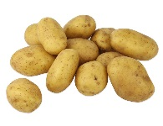





Safety in the Sun and Outside

This term the children will be playing and learning outside much more. Please send them to nursery in tops that cover their shoulders. Children will also need a pair of socks in their bag for forest school if they do not come to nursery in socks.

As the weather gets (hopefully!) warmer please ensure you apply suncream to your child before they come to nursery. If your child is in the Rectangle Group please also give a labelled bottle of suncream to your child’s keyworker so it can be reapplied at lunchtime. Children will be encouraged to do this themselves with supervision and assistance from staff.

All children will also be required to wear a sunhat outside. We have purchased

enough hats for the children out of School Fund, however the children can

bring their own hat if they want to, but please remember to put their name in it.





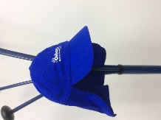

Unwanted Objects we can Re-use

If you have any old CDs that you no longer want please bring them into nursery

as we can use them for craft projects.

We can also re-use in our mud kitchen any old cooking pans and metal or wooden utensils that you may not need any more.



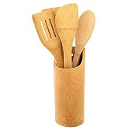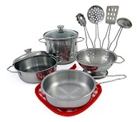

Explorers

This month the children will be learning about the life cycle of a duck through our living eggs programme. They will watch carefully what happens to the eggs as they crack, the baby ducklings hatch out and grow over time. They will also have the opportunity to handle a duckling!

Come and have a look once they have hatched when you drop off or collect your child so that you can talk together about what you see and share the wonder with them!

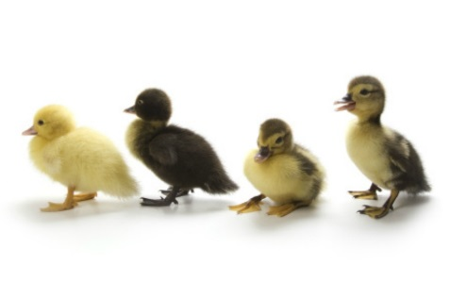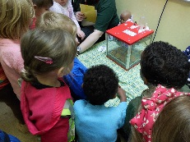

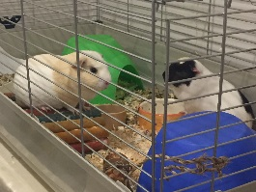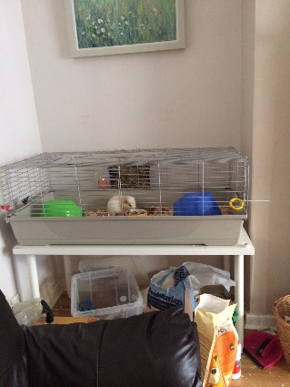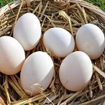

Little Learners

This month we will be having two guinea pigs called Tom and Mr Pibbles come to stay in Little Learners for a few days. The children will be learning how to look after them and will be able to feed and stroke them.