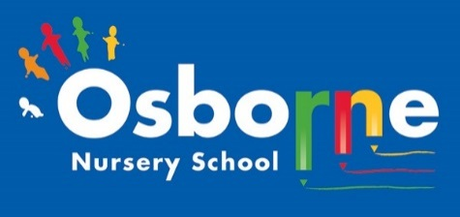**Osborne News**

**March 2019**

www.osbornenurseryschool.co.uk

Health for Life Activities

Little Learners have started ‘Wake Up, Shake Up’ sessions on Tuesdays and Thursdays to get their bodies moving as part of our Health for Life Award. It looked last week as if they were having lots of fun whilst learning to control their bodies as they moved.

Dates:

Mon 4th Mar – **Explorers** **Story time with parents** **& carers** (Fri 8th for end of the week children)

Tues 5th Mar – **Little Learners** **Story time with parents & carers**

Thursday 7th March – **World Book Day** – Explorers and Little Learners can come to nursery dressed

as a book or film character.

Week beginning 11th March – Individual **Parent /Carer meetings** with keyworkers – book a time with your keyworker

* Mon 11th Squirrels & Badgers
* Tue 12th Triangles
* Wed 13th Squares
* Thur 14th Circles, Caterpillars & Tadpoles
* Fri 15th Squirrels & Badgers

Wed 13th Mar – **Bump in the Night** – Squares & Rectangles will have a theatre workshop from

the Play House Theatre.

Wed 27th Mar – **Play & Learn with Your Child** in Explorers with an early writing skills focus, join your child for some or all of their session.

Wed 10th Apr – **Easter Celebration Day** - join your child for some or all of their session to do a variety of Easter themed activities.

15th – 26th Apr – Easter holiday, nursery closed



World Book Day

Remember to come to nursery dressed as your favourite character on 7th March for World Book Day. We’ll give you a token that you can exchange at book shops for a free book. These are some of the free books you can get with your token:







Cool Kittens

with the best attendance for February were

**Caterpillars am Group in Little Learners**

with 95% average attendance

and

**Squares am Group in Explorers**

with 92% average attendance







Play & Learn with your Child Day

Early Writing Skills

Join your child on 27th March to see the activities that help your child strengthen the muscles in their hands and arms ready for writing and how our older children learn to write.

Easter Celebrations

Join your child for all or part of their session on 10th April as we celebrate Easter with activities such as egg and spoon races, an egg hunt in the garden or make an Easter bonnet together.

**