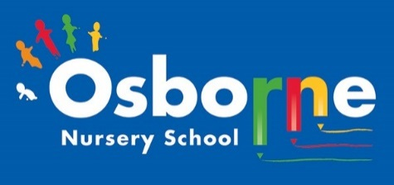**Osborne News**

**May 2019**

Dates:

Monday 6th May – **May Day Bank Holiday** – nursery closed

Wed 8th May – **Class Photos** by an external

Company; Academy Photography

13th – 24th May – **Living Eggs** – come and see what hatches out of our eggs this year when you drop off or collect your child.

Wed 22nd May – **Play & Learn with Your Child** in Explorers with a focus on learning through the natural environment and keeping healthy, join your child for some or all of their session. (Explorers)

27th – 31st May – **Half term holiday**, nursery closed

Friday 7th June – **Eid Celebration Day**

www.osbornenurseryschool.co.uk

Nursery News:

Welcome to all the children and families who joined our nursery this term, please speak to your key worker if you have any questions.

This term the children will be doing lots of activities outside so could you please send them to nursery in footwear that allows them to run, climb and jump.

Strappy sandles and flip-flops are not suitable for nursery and can be dangerous.





Cool Kittens

with the best attendance for April were

**Caterpillars am Group in Little Learners**

with 89% average attendance

and

**Badgers Group in Explorers**

with 93% average attendance

Reception Places for September 19

Children born between 1st September 2014 and 31st August 2015 will be going to Reception class in a primary school in September 2019. If you haven’t received confirmation of your child’s place please seek advice from Elaine in our school office.



Growing Competitions

Explorers

We have just started our annual potato growing competition in Explorers. Each group has a pot full of potato plants which they will have to look after this term. We’ll see which group grows the biggest potato and the most?

Little Learners

Little Learners are busy growing strawberries and tomato plants and learning how to keep them alive.

Play & Learn with Your Child

Join your child on 22nd May to do lots of activities which use the natural environment to help the children learn. Play with the chicks, go minibeast hunting, make a picture with natural objects and visit Forest School.

Please also bring an old container from home (mug, boot, teapot, baked bean can etc) to plant some seeds in with your child.



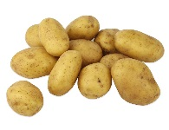

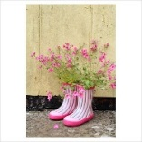

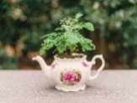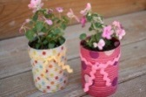

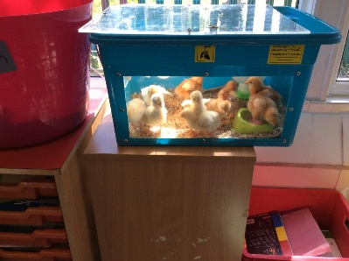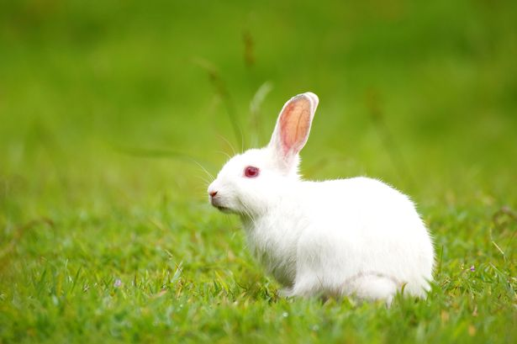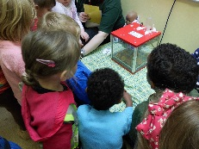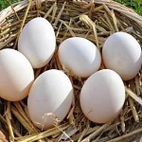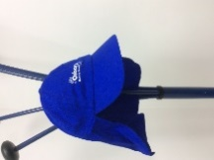

Governors

We will soon have a parent governor vacancy on our governing board. This voluntary post is for two years and involves attending about six governor meetings a year, reading meeting papers, being involved in the strategic direction of the nursery and occasionally meeting with individuals from our staff team to find out specific information on behalf of the governors. No experience is needed but you will need to attend some governor training. For more information speak to Sharon Eeles or our current parent governors Debbie Hill and Adelina Racea.

Little Learners

This month we will be having a visit from Tram’s rabbit, Bailey, in Little Learners. The children will be learning how to look after him and will be able to feed and stroke him.

Explorers

This month the children will be learning about the life cycle of a chicken through our living eggs programme. They will watch carefully what happens to the eggs as they crack, the baby chicks hatch out and grow over time. They will also have the opportunity to handle a chick!

Come and have a look once they have hatched when you drop off or collect your child so that you can talk together about what you see and share the wonder with them!

Safety in the Sun and Outside

This term the children will be playing and learning outside much more. Please send them to nursery in tops that cover their shoulders. Children will also need a pair of socks in their bag for forest school if they do not come to nursery in socks.

As the weather gets (hopefully!) warmer please ensure you apply suncream to your child before they come to nursery. If your child is here all day please also give a labelled bottle of suncream to your child’s keyworker so it can be reapplied at lunchtime. Children will be encouraged to do this themselves with supervision and assistance from staff.

All children will also be required to wear a sunhat outside. We have purchased

enough hats for the children out of School Fund, however the children can

bring their own hat if they want to, but please remember to put their name in it.