Home

Learning

Booklet

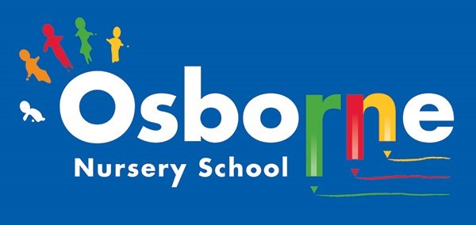

**Maths**

Counting games—During everyday tasks introduce numbers and counting e.g. as you climb the stairs count them, as you put on shoes count them 1, 2 shoes etc.

Can your child sort their toys—maybe they have a pile of cars and a pile of teddies.

Build a tower with blocks/bricks—challenge your child to build a tower as tall as themselves! If you don’t have blocks you could use boxes or tins from the cupboard.

**Communication and Language**

Encourage the use of language by giving your child a choice e.g. Would you like milk or juice? Children are encouraged to use a word instead of an action (like nodding/shaking head)

Play a sound game - if you have any items around the house that make a noise e.g. packet of rice/pasta, pots and pans with a wooden spoon, your phone—play the sound and encourage children to guess which object made the sound. You could also listen to what sounds you can hear around your home—you may hear sirens outside or dog’s barking. This activity helps develop your child’s listening and attention skills.

**Activities for 2 year olds**

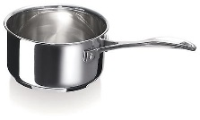

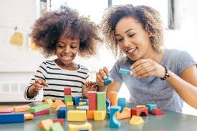

**Literacy**

Share a story with your child each day. Bedtime is a great time to share a story. Talk to your child about the pictures - what can they see?

Sing simple nursery rhymes together e.g. Humpty Dumpty, twinkle little star or maybe baa baa black sheep.





**Physical**

Can your child kick/throw a ball?

Using a pen/pencil to mark make—can they copy a line or circle? If not you could practice making marks in a tray of rice/salt with your fingers.

Using play dough to develop children’s fine motor skills (develop small muscles in hands and fingers) You could add items like pasta, spaghetti, buttons or pebbles to your dough creations. If you have a garden you could find twigs or leaves to add to your dough.

**Expressive Arts and Design**

Make your own musical instruments such as using an empty container and some rice to make a shaker. Experiment with making loud and quiet noises.

Encourage your child to explore different textures, with their hands e.g. paint, mud, sand, leaves, sponges, rice, flour introduce language such as soft, smooth, rough to describe them.

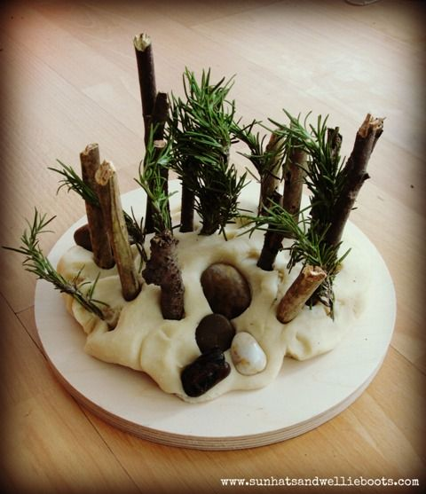

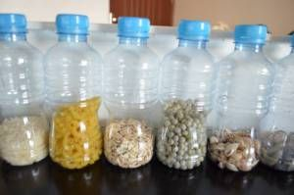

**Understanding the world**

You could create your own sensory basket at home with household items such as wooden spoons, rolling pin, saucepan, colander, measuring spoons, egg cups, cake moulds. Use the baskets to allow your child to explore the different materials and their properties.

Look at some photos of different family members– talk to your child about who they are and their names. (This could be on your phone or printed photos).

**Activities for 2 year olds**

**Personal, Social and Emotional**

Play a simple game with your child that requires them to take turns e.g. rolling a ball to each other. Building a tower together and taking it in turns to add the next brick or taking turns to post items into a box. (simply use an empty box/packet and make a hole in the lid that things that can be posted through).

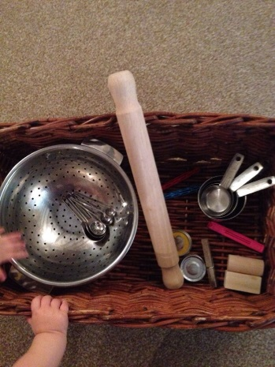

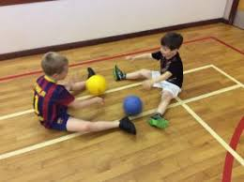

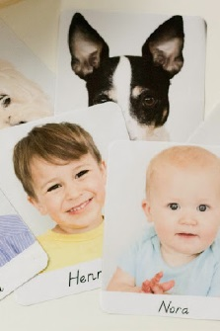

**Useful links**

<https://beaconschoolsupport.co.uk/parents/supporting_children_at_home.php> - helping children with their

behaviour and emotions.

<https://home.oxfordowl.co.uk/kids-activities/learning-activities-for-toddlers/> - activities for 0-3 year olds

<https://www.funkyfeetmusic.co.uk/> - lots of songs and rhymes to keep children active.

<https://www.bbc.co.uk/cbeebies/topics/numeracy> - number activities and games.

<https://theimaginationtree.com/40-fine-motor-skills-activities-for-kids/> - activities to help develop fine motor skills.

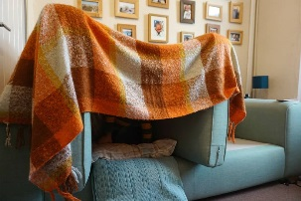

**Communication and Language**

Understanding is an important part of communication. These activities help support this as part of learning early language.

Verbs/Doing words— Play copy me action games with your child. Show your child a range of movements e.g. jumping, dancing, clapping, nodding, stomping and name them and encourage your child to copy you. Can your child name them? If it’s too difficult you could give them a choice e.g. “Are you jumping or clapping?” You could also do this with a teddy or other toy.

Talk to your child during simple routines e.g. when washing or getting dressed keep your language simple “wash hands”, “wash face”, “socks on”, “trousers on”. In time your child will learn and copy the language.

**Maths**

Enjoy making a den with your child or for one of your child’s toys—can they make a den big enough for them to fit in. While your making it you can introduce language about big and small.

Make some coloured rice at home (used uncooked rice, add some food colouring and mix together—let it dry before playing with it) Put the rice in a tray or bowl and add some different size spoons and containers which your child can enjoy filling, transferring and emptying the rice.

**Activities for 2 year olds**

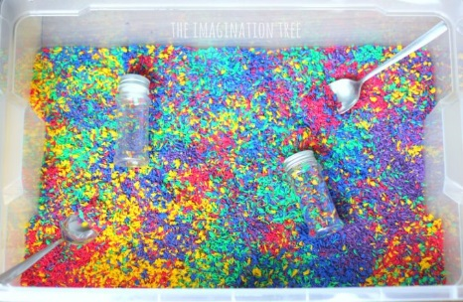



**Literacy**

Writing begins as mark making and for younger children this can be a very sensory experience. You could use paint and various household equipment to make marks—you don’t need a paintbrush—you could use a washing up brush, a fork, cotton buds, even just fingers to make marks in the paint or alternatively you could use a mix of cornflour and water or even shaving foam to make marks in!

Keep sharing books with your child —bedtime is an ideal time, but any time of the day is good!

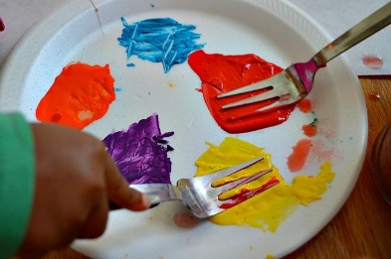

**Expressive Arts and Design**

Edible paint—Make some edible paint with your child (recipe at back of booklet) You could paint with fingers, cotton buds, hands or even foot prints!

Music and movement—children express themselves in a number of ways and dance is great way to learn not only physical skills but rhythm too which will help support early literacy skills. YouTube has lots of free funky feet videos you can use!

https://m.youtube.com/watch?v=ZhLD8315nZA

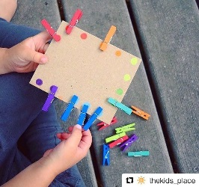

**Physical**

Your child could help you with hanging up the washing using pegs to hang up the clothes or alternatively attaching pegs onto a piece of cardboard—great for finger muscle development!

Using some tweezers or kitchen tongs to transfer items between bowls. You could use beads, rolled up socks, pom-poms if you have any.

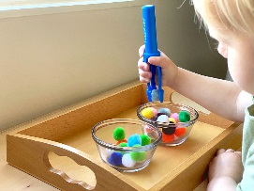



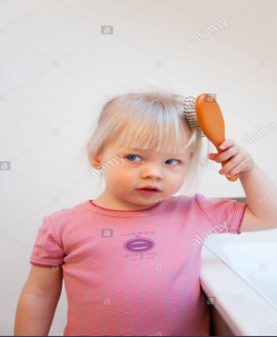

**Understanding the world**

Create a self-care basket that you can share with your child - it should include things like hairbrush, comb, soap, toothpaste, toothbrush, sponge, empty shampoo bottle -explore the different items, demonstrate and talk about what each item is for. Let your child have a go too.

Encourage your child to help at tidy up time. Can they put their toys back in the right place?

If you have any toys or real objects with buttons or switches they can learn how they work looking at cause and effect.

**Activities for 2 year olds**

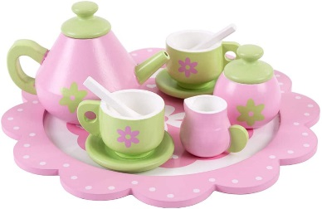

**Personal, Social and Emotional**

Pretend play - You could give your child some clothes they could dress up in or some dolls/teddies, cups and plates where they can role play different situations.

Developing interaction skills - joining in with your child’s play. Observe your child playing taking note of what they enjoy and join in by copying your child or taking their lead on what they want you to do. While you’re playing comment and talk about what your child is doing, repeat what they say and expand on it e.g. your child says “train” you could expand by adding 1 or 2 words saying “yes it’s a blue train” or “yes the train is going fast”.



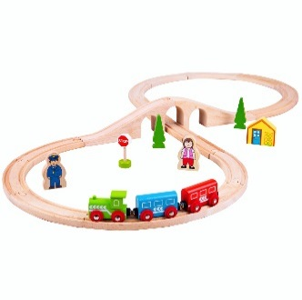

**Useful links**

<https://www.funlearning.co.uk/toys/for-3-year-olds/easy-grip-childrens-tweezers/> - children’s tweezers

<https://www.funkyfeetmusic.co.uk/> - lots of songs and rhymes to keep children active.

<https://www.youtube.com/watch?v=6FHOwD7Lp9Q&safe=true> - Funky feet videos on you tube.

<https://praacticalaac.org/praactical/soundmusic-cause-and-effect-apps-for-engaging-aac-learners/> - apps for cause and effect toys

**Bucket time**

The aim is to support the development of children's attention, listening and communication skills whilst having fun! The activity is entirely adult - led, with a focus on the children observing what the adult is doing. Activities should be kept short at first in order to hold the children's attention.

The resources needed are very simple and can usually be found at home. Items needed are:  
* A bucket or container with a lid on to put items in,  
* Engaging toys that children will enjoy watching (e.g. toys with flashing lights, spinning tops, wind-up toys, noise makers, 'party - favour' type items etc.)  
* A pen and a whiteboard or a piece of paper/card/notebook etc. (to draw a bucket to  
symbolise 'bucket time' is 'now' and another activity is 'next').

Adults demonstrate one item at a time from the bucket in front of their child.  
If your child gets up to touch the items, gently guide them back to their space. This is to encourage attention and listening skills. As the children's attention begins to grow, the activity can be extended to include different activities after the 'bucket' activity including using playdough, paint, foam etc. At this stage though, keep it simple and have fun!

Have a look at the clips and give it a try at home, and please let us know how you get on! :)

<https://www.youtube.com/watch?v=FWJhjJF8ES0>

<https://www.youtube.com/watch?v=glktGBCRqM4>

<https://www.youtube.com/watch?v=m2RiYnluVXY>

**Water play**

Using a bucket or bowl or water tray if you have one add water (you could add bubbles or food colouring) and various different containers (different size spoons and bottles, pots) that your child can practice pouring the water and emptying and filling different containers.

**Threading Beads**

Threading beads onto string/wool or pipe cleaners if you have them. Or you could use pasta or cheerios if you haven’t got any beads. (The cheerios could then be hung out for birds if you have a garden.) Threading is a fantastic activity for promoting fine motor development in young children. It requires concentration, thinking skills, encourages the use of the pincer grasp between the thumb and forefinger and naturally strengthens the small hand muscles that are vital for holding a pencil to write with later on.

**General Activities for 2 Year Olds**

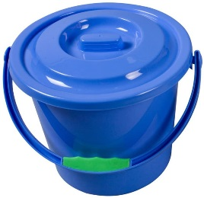

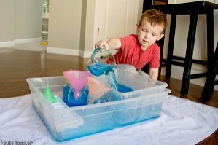

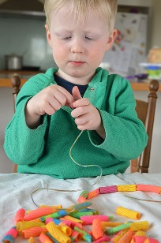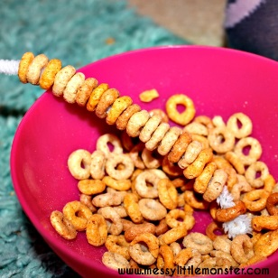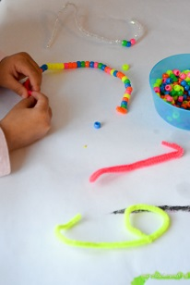

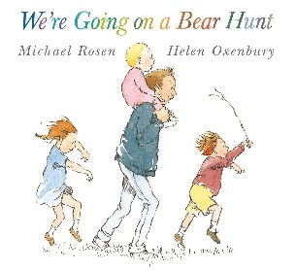

**Communication and Language**

Share a well-known or favourite book with your child several times throughout the week. Children learn well when exposed to stories lots of times!

Post boxes activity— using pictures or toys—can your child understand and follow instructions with 2 key words e.g. “can you find the blue car?” “Can you find the big teddy?”. If you are able to find pictures (either printed off or cut out of magazines) they could post the pictures into a box e.g. “Find the boy sleeping”.

**Activities for 3 year olds**

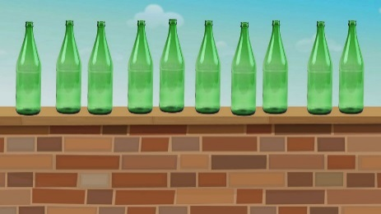

**Maths**

Sing number rhymes with your child e.g. 10 green bottles, 5 little ducks. Can they count the number on their fingers?

Go on a shape hunt around your house. Can your child find a circle, square, triangle or rectangle?

Go on a number hunt around your home e.g. on the remote control, on an oven or washing machine. Can they identify any numbers?

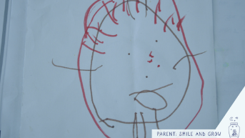

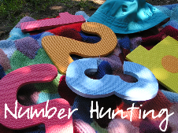

**Expressive Arts and Design**

Practice drawing lines and circles to represent objects or people. You could draw one first for your child to copy. Encourage them to add more detail if they can and to talk about what they have drawn.

Encourage your child to explore different textures, paint, mud, sand, leaves, sponges introduce language such as soft, smooth, rough to describe them.

Sing some simple ring games and rhymes with your child e.g. Ring a ring a roses.

**Physical**

Water play— using a bucket or bowl or water tray if you have one add water (you could add bubbles or food colouring) and various different containers and spoons that your child can fill and empty. You could introduce quantity e.g. how many spoons does it take to fill up the cup? Introduce language such as ‘full’, ‘empty’, ‘half full’ ‘half empty’.

Can your child use hold and use scissors? You could give them a magazine or newspaper they could cut out pictures from or just give them some paper/card they can practice making snips in.

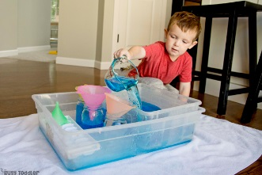

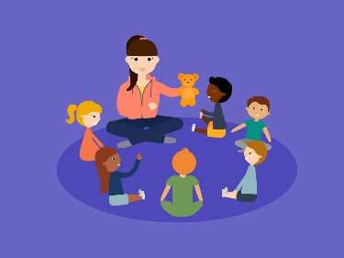

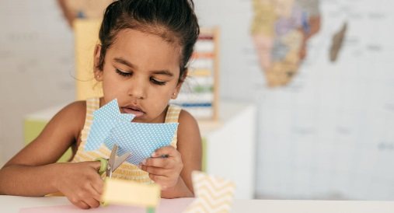

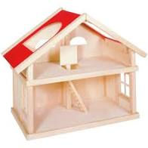

**Understanding the world**

Enjoy playing with any small world toys you may have at home e.g. train track, dolls house, farm etc. While playing you could introduce some new language about the toys or place you are playing with.

If you have a garden you could go on a Mini beast hunt. If not, you could watch some videos or programmes on Cbeebies to learn about different minibeasts. Crazy critters is a good one.

https://www.youtube.com/watch?v=JuHg5oWF_mo&safe=true

**Activities for 3 year olds**

**Personal, Social and Emotional**

Young children are still learning about their emotions. Can your child think of something that makes them sad or happy, worried or angry? You could draw picture or find photos of people displaying these feelings to show your child.

Play a simple game with your child that requires them to take turns e.g. rolling a ball to each other.

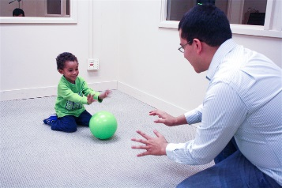



**Literacy**

Share a story with your child each day. Bedtime is a great time to share a story. Talk to your child about the pictures - what can they see?

When singing nursery rhymes together, can your child finish the sentence? E.g. Humpty Dumpty sat on a ……….?”



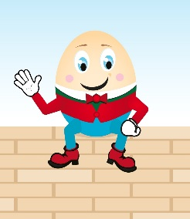

**Useful links**

<https://beaconschoolsupport.co.uk/parents/supporting_children_at_home.php> - helping children with their behaviour and emotions.

<https://home.oxfordowl.co.uk/kids-activities/learning-activities-for-toddlers/> - activities for 0-3 year olds

<https://www.funkyfeetmusic.co.uk/> - lots of songs and rhymes to keep children active.

<https://www.youtube.com/watch?v=lzc_Rd4TuYg&safe=true> - nursery rhymes on you tube.

<https://www.pinterest.com/pin/358599189065094713/> - Ring games and songs

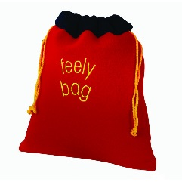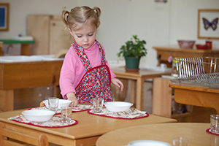

**Communication and Language**

Feely bag - Choose 5 everyday items e.g. doll, teddy, car, hairbrush, ball, cup to put in a canvas or pump bag (any bag you can’t see through) 1 at a time take each item out to explore, name and model what you do with them. Then put them all back in and allow your child to take 1 or 2 items out of the bag—encourage them to name them or ask them “where is the ball?”.

Pretend you’re a superhero for the day! Discuss with your child and choose a superpower you could have for one day will it be super strength? Super speed? Super tidy-upper? Can you fly? Encourage your child to talk about their super power throughout the day and what they can do with it.

**Activities for 3 year olds**

**Maths**

Helping with everyday tasks— How many plates do we need for lunch? How many pairs of socks in the wash? Can your child help match the socks in pairs? Can you get me 3 spoons/forks etc?

Sorting by size, gather some toys or teddies for your child to sort by size. Can they find the biggest, smallest and middle sized object? You could introduce language such as ‘bigger than’ or ‘smaller than’.

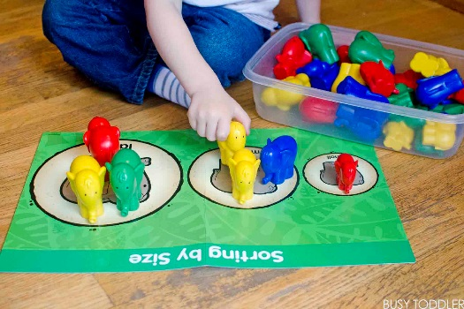



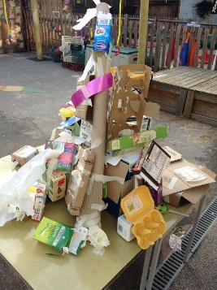

**Physical**

Copy me— Play a game of copy me you choose a movement and then the child copies you. Take it in turns to be the copier/mover.

Indoor assault course—This doesn’t need to take up a lot of space you could use cushions to climb over, string or tape on the floor to use as a tight rope, a chair to crawl under, a table (maybe with a blanket over it) to make a tunnel to go through. As a challenge you could time how long it takes them?

**Expressive Arts and Design**

Making a junk tower— Using empty boxes, food packets, rolls, bottles and lids etc. make a tower or whatever your child would like to make—could be a robot or a car—If you have them you could use tape, string and scissors to add to your creation.

Making music— You could use pot and pans with a spoon, tapping on the table—vary the way you play e.g. loud, quiet, fast and slow. You could play along to music or just make your own!

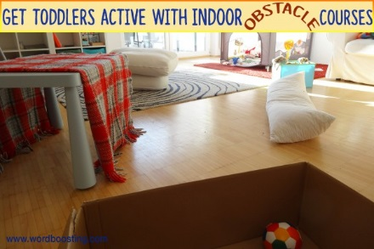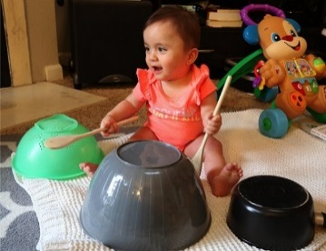

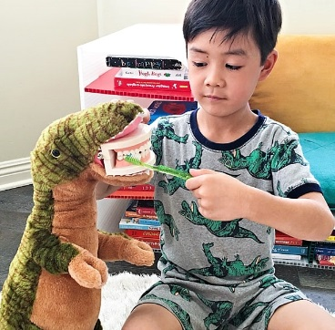

**Personal, Social and Emotional**

Making a choice—Throughout the day give your child options of 2 things and ask them to choose one e.g. “Would you like an apple or banana?” “Shall we watch Peppa Pig or Paw Patrol?” If able can they explain why they made that choice?

Send a song or message—Record messages/videos for family messages that you can send to them—you could sing a song for them, or tell/show them something you have done.

**Understanding the world**

A day in the life of teddy/doll/dinosaur...Ask your child to choose one of their toys that they need to look after for the day. The toy will need help to get up, get dressed, eat, play with friends, go to bed. You could take photos throughout the day to look over another time and talk about the different things the toy did.

Make a book or poster about your family—you could use photos if you have them (you could ask family members to send some) or draw them—remember to include pets if there are any. Talk with your child about who everyone is including names or relation e.g. aunt/uncle. This could be something you could revisit and add to over time.

**Activities for 3 year olds**

**Literacy**

Reading stories with your child—if your running out of books remember there are plenty of free e-books online you could use!

Make some simple labels for objects around your home like shoes, coats, cups etc.—encourage your child to make marks on the labels—depending on where your child is developmentally this could be marks, drawings or letters.

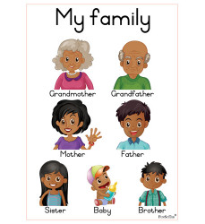

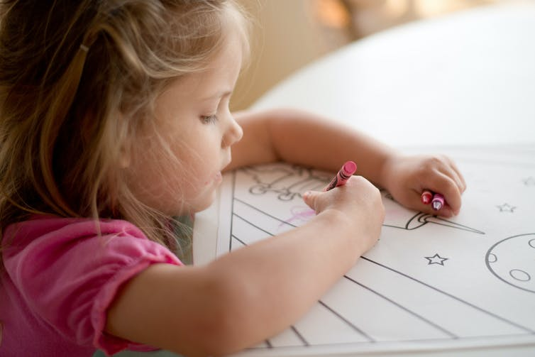

**Useful links**

Online e-books

<https://stories.audible.com/>

<https://home.oxfordowl.co.uk/storyteller-videos/> <https://www.lovereading4kids.co.uk/genre/ebk/eBooks.html> - Kindle books

Sounds of Play/Music

<https://www.youtube.com/watch?v=g-WI4bVELMI&feature=youtu.be&safe=true>

<https://www.youtube.com/watch?v=F5GQLVavSpg&safe=true>

**Maths**

Sing number rhymes with your child e.g. 10 green bottles, 5 little ducks. Can they count the number on their fingers? Can they count forwards and backwards to 10? Can they count beyond 10 up to 20 or higher?

Go on a shape hunt around your house or in the garden if you have one. Can your child find a circle, square, triangle or rectangle? Can they talk about the properties of the shapes—how many sides, how many corners do they have?

Go on a number hunt around your home e.g. on the remote control, on toys, clocks etc. Can they identify any numbers? Can they find something with numbers 1-10 on it? Can they order the numbers 1-10?

**Communication and Language**

Can your child put a favourite toy in different places around the room using this language ‘under; ‘on top’, ‘behind’ , ‘next to’ , ‘inside’ e.g. can they put their teddy under the table?

Share a well-known or favourite book with your child several times throughout the week—children learn well when exposed to stories lots of times! Can they begin to retell parts of the story themselves?

**Activities for 4 year olds**

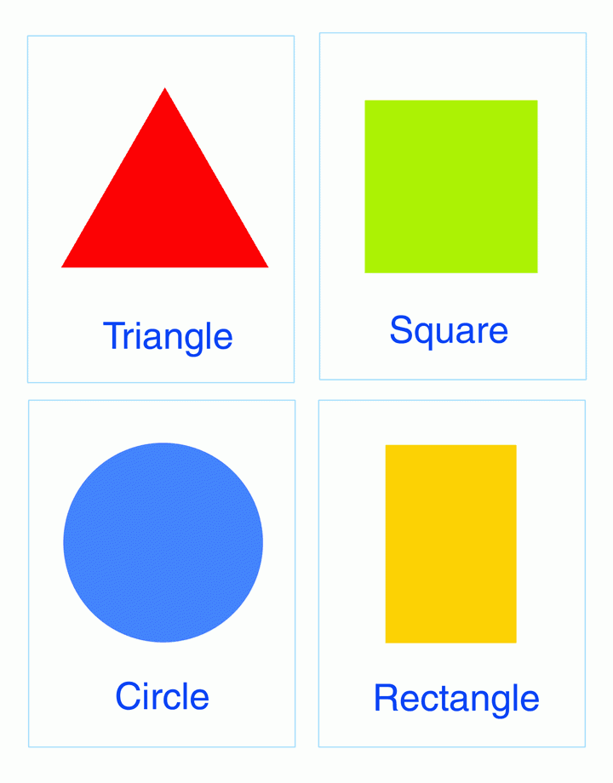

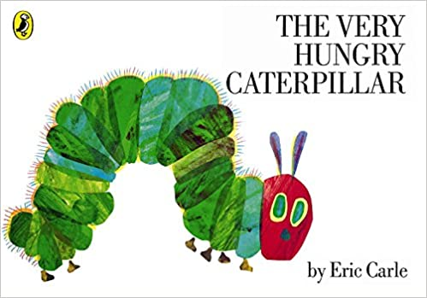

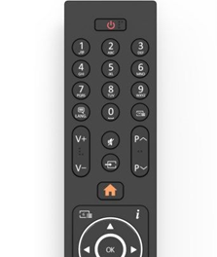

**Expressive Arts and Design**

Ask your child to draw a picture of their whole family. Can your child talk about and name them all? Can your child talk about some of the similarities and differences between family members?

Create your own story! - This activity helps introduce story language such as ‘character’ ‘setting’, ‘problem’, ‘solution’ ‘Once upon a time’. Your child can choose the character—it could be one of their favourite toys and you can help them build the story by asking questions such as “Where is your story set? A forest, a beach, a house?” As the adult you could write the story down or maybe record what they say.

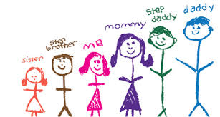

**Physical**

Set your child a challenge—can they move around in different ways—slither, crawl, jump, hop, roll, walk, run, skip, slide? You could set up an obstacle course in your house to try some different movements—A sheet over the table to make a tunnel, a chair to climb under...

Can your child use different tools? Maybe they could help cut up some fruit with a knife or butter their own toast?

Can they use scissors? Learning how to hold scissors correctly and safely and practice cutting along different shape lines or cutting out pictures from a magazine?

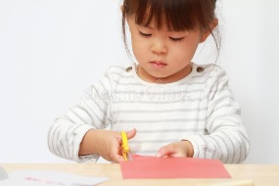

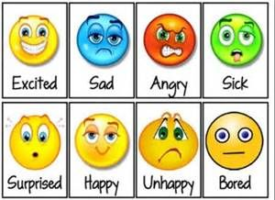

**Understanding the world**

Can your child talk about a special family event maybe a birthday or religious celebration? How do you celebrate, what kind of things make it special? Is it held at a particular time or place? Who attends?

Lots of items around the home have knobs, switches or buttons to make them work in a certain way e.g. washing machine, TV remote, oven—how many can your child find? Spend time exploring the items talk about safety what makes them work—if they have batteries you could take them out to show and talk about. To explore further you could draw a picture together of a robot with lots of switches and buttons - what does each button/switch make the robot do?

**Personal, Social and Emotional**

Young children are still learning about their emotions. Can your child think of something that makes them sad, happy or worried, scared or angry? Can they talk about how some things make them feel?

Play a simple game with your child that requires them to take turns e.g. rolling/throwing a ball to each other or playing a board game like snakes and ladders.

**Activities for 4 year olds**

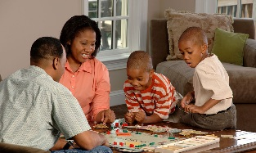

**Literacy**

Share a story with your child each day. Bedtime is a great time to share a story. Talk to your child about the story. What do they think will happen next?

Follow a simple recipe to cook something together. (There are some simple recipes at the back of this pack).

Make playdough together to play with following a simple recipe (recipes at back of pack). Playing with this material will help strengthen their fingers which will help develop good pencil control later on.



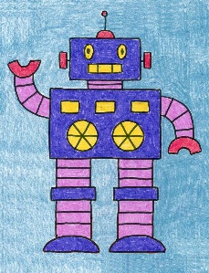

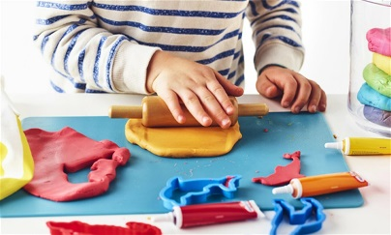

**Useful links**

<https://en.calameo.com/read/000777721945cfe5bb9cc?authid=Xu9pcOzU3TQx> Everybody worries story to help with anxiety.

<https://beaconschoolsupport.co.uk/parents/supporting_children_at_home.php> - helping children with their behaviour and emotions.

<https://famly.co/blog/inspiration/eyfs-focus-9-activities-to-help-kids-in-understanding-the-world/>- Activities for all ages.

https://www.phonicsplay.co.uk/ - Free at the moment for phonics games and activities.

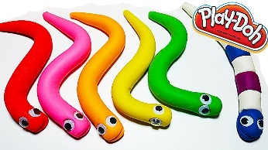

**Activities for 4 year olds**

**Maths**

Play dough Caterpillars/snakes—learning about length. Roll the dough into different lengths to make snakes or caterpillars. Encourage the use of long and short rather than big and little. You could then extend by looking around the house for long/short things—socks are a great idea to sort by length.

Sharing and problem solving—Using a cake or some fruit can you decide how you are going to share it? How could you cut the cake/apple—knife, scissors how many pieces do you need so all the family can have some? Is it fair—has everyone got the same amount? You could do this activity with playdough.

I’m on top of it game—Learning about where things are in relation to other things. Ask your child to choose a toy to place in relation to a chair - on top, under, behind, beside, in between, next to—if your child chooses a small toy you could use a box or small container or your child could move themselves.

**Communication and Language**

I see a….. Describe an item/toy for your child to guess what it is e.g. jumper—I see something blue, small, soft, bobbly, stripy, spots.

Sock puppets—use a couple of old socks—your child could decorate them by cutting out paper to make eyes etc. or material if you have it. Encourage your child to name the puppet—use a funny voice to talk, the puppet could tell a story or give instructions.

Recorded family member voices—can they guess who they are

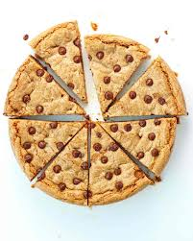

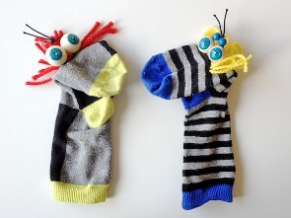

**Expressive Arts and Design**

Make a junk model—raid your recycling bin looking for empty boxes, tubes, pots etc. choose something to make then work out how are you going to fix them together glue, tape, pins, staples etc. Encourage your child to think of different ways and challenge them if there was no glue what would we use?

Turn your sofa into a boat for the day! Work together to turn your sofa or a chair into a boat—will it have a mast (broom), sails (sheets/tea towel), wheel (bowl), oars? You could look at a book with a boat in to help your child think of ideas or search on the internet for images. You could even cut out fish and sharks from paper and place them on the floor for the sea. Maybe pack a snack and go on a voyage!



**Physical**

Getting dressed—Encourage your child to dress more independently - they could choose what they are wearing and then put it on themselves - can they put socks and shoes on, put their t-shirt on. Try to start with clothes that are easy to put on e.g. elasticated waist bands no buttons or laces initially.

Using a Pincer grip to pick up objects. Gather some small objects from around the house and 2 bowls or trays to move them between. Encourage your child to use their pincer grip (Thumb and first finger) to pick up the items and move them from one try to another. If you have tweezers, chopsticks or tongs you could challenge them to pick up and move the items with those.



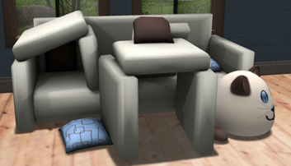

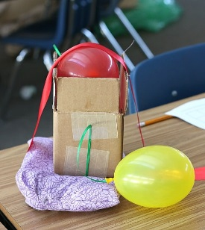

**Personal, Social and Emotional**

Good to be a star—A simple activity where children can think about what makes them special and unique. Draw a 5 pointed star on some paper and encourage your child to think of 5 things about themselves e.g. Are they a good friend, are they helpful? Have they got any skills e.g. riding a bike without stabilisers? This is a great opportunity to talk about differences/similarities between people.

**Belly breathing and Monster Meditation**

Been stuck at home can be stressful and frustrating for adults and children. These clips from Sesame Street give some tips of managing frustration and calming fears.

<https://www.youtube.com/watch?v=J9nE4RE8uiQ>

<https://www.youtube.com/watch?v=Xq3DwzX6MUw>

**Understanding the world**

Egg drop experiment

You may need a couple of eggs for this, one to test initially! Drop an egg from a height (Arm reached up high is fine or if you have something higher even better. Discuss what your child thinks might happen (Will it crack? Or will it survive?) Then think about a way to drop the egg and keep it intact—make something for the egg to travel in—e.g. box with parachute, in a box wrapped with something? What works/doesn’t work?

Foaming fizz—you will need bicarbonate of soda, vinegar, washing up liquid and food colouring if you have it. Experiment adding the different ingredients together. What happens? What happens if you miss out one ingredient? Why do they think it happens? Could we add a different ingredient?



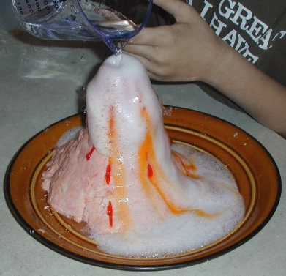

**Literacy**

Syllable clapping - Clapping out syllables of words will help children with reading as they get older. Try clapping out syllables to simple short words to start with and then extend as needed. E.g. Spi-der has 2 syllables so 2 claps. You could use names of family members, or week days as well as everyday objects.

Rhyming words - Try finding rhyming words to simple words e.g. what rhymes with log? - bog, sog, dog (they don’t have to be real words if they sound the same. If this is too difficult you could make it a choice game—which one doesn't rhyme?



**Useful links**

Science Experiments— <https://www.sciencefun.org/kidszone/experiments/>

Activities for 4 Year olds— <https://home.oxfordowl.co.uk/kids-activities/learning-activities-age-4/>

Ideas and Activities for 4 year olds— <https://hungrylittleminds.campaign.gov.uk/#3>

**Problem Solving** - Take some close up photos of objects or parts of objects from around the house and challenge your child to use their good thinking skills to find those objects. You could vary it by just having photos of things that start with a certain letter or you could write down a list of the objects you find as you find them and encourage your child to have a go at writing too.

**Kim’s Game -** This is a great little memory game you can play with your child. Choose 5 random objects from around the house and put them on a tray or plate. Name all the objects with your child making sure they know what each one is then cover with a tea towel or blanket. Tell your child you are going to cast a spell and one of the items will disappear. (remove one item along with the tea towel) and ask your child to name the missing object. You can make it more difficult by taking away more items or adding more items to the tray/plate.

**Superhero Sorting Activity -** Explain to your child that their favourite superhero needs their help by finding objects from around the house that are a specific colour to give them a power boost. E.g. for the hulk you could find green things. You could have a letter written by their favourite superhero to explain the activity. When your child has found some you can talk about the objects, what they are and what they look like. You could make the challenge harder by asking for objects with 2 colours on or by setting a timer on your phone.

**Duplo Lego Challenge -** Set your child/children a timer challenge using the timer on your phone (30 seconds/1 min) etc.  
What is the tallest tower they can make for Rapunzel to escape the witch?  
What is the widest wall they can make for Humpty Dumpty?  
What is the longest Hungry Caterpillar they can join together?

Make more tricky by changing the rules e.g. they can only use blue bricks etc.   
You can introduce the concept of pattern - the tower must be a yellow and green repeating pattern etc.

If you haven’t got any building blocks you could use packets and tins from the cupboard.

**Musical Bumps/Statues Yoga -** This is a game we play at Nursery with the children and they really enjoy it. Put on some lively music and dance to it - swaying, spinning, stretching, running on the spot etc. then when you stop the music the children have to take a yoga shape and hold it still until the music begins again. It's just a variation on musical statues or musical bumps really but doing the yoga positions makes it more tricky, especially the balances. Some of the yoga shapes we know are the tree, aeroplane, dancer, cat, dog, boat, bridge, cobra, frog, rock. Take it in turns to choose the yoga shapes (You can find examples of these movements online).

**General Activities for 4 year olds**



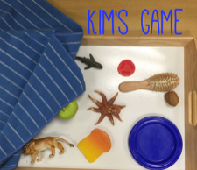



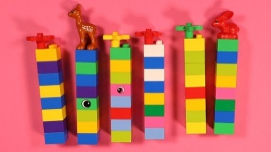

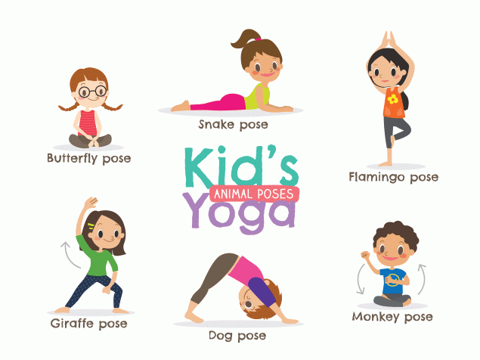

**Guess the present challenge -** Who doesn't love a present?! This activity is fun and also good for thinking and problem-solving. Wrap up some objects and or toys in newspaper (about 10) - try and vary the shapes and textures e.g. teddy, small cup, fork etc. You can show your child first or make it tricky and don't show them!  
Ask them to guess what's inside each present. Discuss how the present feels e.g. is it large, small, soft, hard, squishy etc. Try and use lots of descriptive language and encourage your child to do the same. If you want to you can put number labels on the presents and write a list of what your child thinks maybe inside that numbered present. Really good early literacy activity as you can ask the children to think about the letter sounds that the word begins with or what sounds they can hear in the word. Don't open the presents straightaway but encourage your child to wait until after snack time or lunchtime and then ask them to remember what they thought their guess was. Really good for developing self-regulation. An important life skill!

**Blind fold challenge**

This is a good activity for thinking and problem-solving. Have about 5-6 objects e.g. sponge,

metal spoon, soft teddy/toy, hair brush, bar of soap. Show your child the objects and discuss

how they feel using good descriptive language, e.g smooth, cold, rough, prickly. Name the

items if your child/children do not know the name.  
You can then ask the children to close their eyes or use a small scarf/sleep mask as a blind-fold

to cover their eyes (some children may not like this so just get them to cover their eyes with

their hands). Hand the child one of the objects and they have to guess which one it its just

from the touch of it. A variation on this is using the child's feet to feel the object rather than

the hands but still ensure that your child can not see the object.

**Meaningful print—logo etc.**

Helping your child to recognise logos is a great way to support early reading skills. Cut out some labels from everyday things e.g. cereal boxes, cans, carrier bags etc. (You could print some out if needed too) until you have a collection. Look at them with your child and discuss what they can see—they may talk about the colour, the letters that they can see or what the logo represents e.g. shop name, type of cereal. You could play a game where you hide the logo with a piece of paper and reveal it slowly and see when the child recognises it. You could tape/stick the logos around the house to be referred to during play.

**Mark Making (pre-writing)**

Mark making doesn’t just have to take place on paper! Here are some ideas you could try;-  
• Have a tray or an area on a table and sprinkle flour and let your child make marks with their fingers. You could use cornflour and water (gloop), rice, sand, or shaving foam. Have a look on the internet for ‘sensory writing’ ideas!  
• If you have a paint brush, sponge scourer, mug mop or washing up brush, let your child paint

with these using water across a large flat surface. E.g. on a wall or floor area. Outside in the garden

would be ideal but a balcony would be a perfect space too!

**General Activities for 4 year olds**



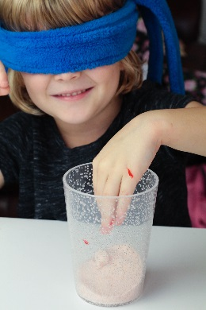



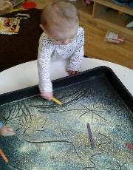

Apps, and technology overall, are another tool for learning. Children get the most out of playing with apps if they are well chosen by you and if you play together. The National Literacy Trust gives the following advice when choosing apps for your children to use:

**Tip 1**  
When choosing apps for your child, it’s useful to consider:

* Your Child: It has to be something they will enjoy and which relates to them specifically
* The Content: Suits their abilities and helps them learn something
* The Community: Apps reflect what your child sees around them
* The Context: Make sure the children are also spending time offline

**Tip 2**  
Watch gameplay footage of the app on YouTube so you know what it does. It’s a great way to get a feel for what your children will be doing before buying.

**Tip 3**  
Things that you should always try to avoid are:

* Violence
* Gender or racial stereotyping
* Pop-up adverts and sales promotion

**Tip 4**  
Exploration is the best form of learning so don’t let yourself or the app be too strict about how your child plays with it.

**Recommended Apps and Websites**

<http://literacyapps.literacytrust.org.uk/> - Literacy Trust Recommendations with a review of each app, who it’s suitable and what skills/learning are been used.

<https://hungrylittleminds.campaign.gov.uk/#information> - Apps and websites suitable for young children (2-5 Years). Links to other useful websites.

<https://home.oxfordowl.co.uk/kids-activities/learning-activities-for-toddlers/> - Apps and online learning activities.

<https://whatmomslove.com/kids/best-educational-apps-for-toddlers-preschoolers/> - Apps for young children - not all of these apps are free.

<https://www.motherandbaby.co.uk/baby-and-toddler/more/toys-and-education/top-10-apps-for-toddlers> - Apps and information on screen time.

<https://www.thelondonmother.net/educational-apps-for-children/> - Educational apps for children aged 2-5 years.

[www.youtubekids.com](http://www.youtubekids.com) - Child/family friendly version of You tube.

**There are plenty of other websites and apps available but please remember to check these out yourselves following the guidance above before allowing children to play.**

**E-safety and Suggested Apps**

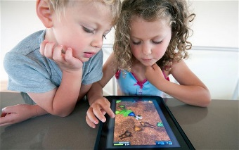

**Victoria Sponge Cake**

225g of self-raising flour  
225g of caster sugar  
225g of softened butter  
4 eggs  
1tsp vanilla extract

Double cream and a filling of your choice jam

1. Mix the butter and sugar together until soft
2. Add the eggs mix well
3. Add flour to the mixture along with vanilla extract
4. Line the tins with greased proof paper if you have it or just brush melted marg onto the inside of the tins
5. Use two round tins and separate the mixture into both tins and level top
6. Bake for 25 minutes at 180 degrees (gas 4) in the oven.
7. When cool spread jam on top of one cake then whip the cream and add on top of the jam.
8. Place the other cake on top.

**Flapjacks**

6oz of golden syrup

6oz of butter/margarine

6oz of light brown sugar

12oz of oats

1. Melt the butter on low heat
2. Add the sugar and syrup
3. Pour on the oats and mix in well.
4. Empty the mixture on to a baking tray
5. Cook at 170-180 degrees (gas 3-4) in the oven for 25-30 minutes.

**Recipes**

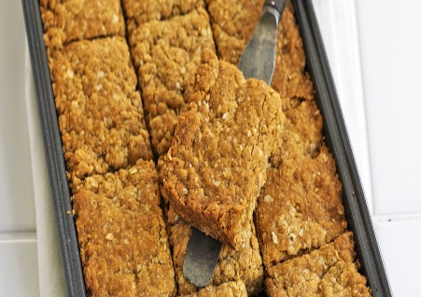

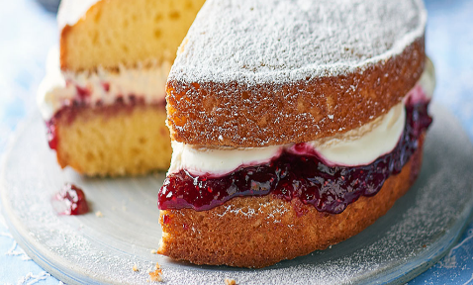

**Cupcakes**

110 g butter, softened  
110 g caster sugar  
110 g plain flour  
2 tsp baking powder  
1/4 tsp salt  
2 medium eggs  
1 tsp vanilla extract

1. Preheat the oven to 180C/ 350F / Gas 4. Line a muffin tin with paper cases.

2. Put the butter and sugar in a bowl and beat until pale and fluffy.

3. Sift the flour, baking powder and salt into the bowl.

4. Beat the eggs and vanilla and add to the bowl. Beat until just combined.

5. Spoon the mixture into the paper cases.

6. Bake for 18 to 20 minutes until risen, golden and firm to the touch.

Cool in the tin for 10 minutes, then transfer to a wire rack to coolcompletely.

**Buttercream Icing**

600g Icing Sugar

300g unsalted butter

Food colouring (optional)

When cool make the icing by whisking the ingredients together and either spoon on top or use a piping bag.



**Recipes**

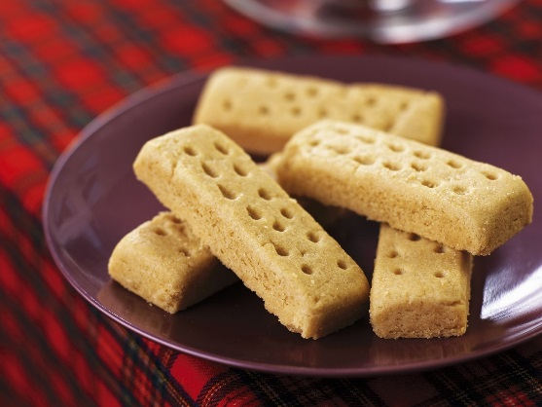

**Shortbread**  
4oz of butter  
2oz of caster sugar  
6oz of plain flour  
Preheat the over to 190C/Gas Mark 5.

1. Beat butter and sugar together until smooth.
2. Stir in the flour until mixture is smooth.
3. Empty bowl onto a work surface and roll out until about 1cm thick.
4. Cut into slices and place on a baking tray.
5. Sprinkle with caster sugar and chill in the fridge for 20 minutes.
6. Bake in the oven for 15-20 minutes or until golden brown.

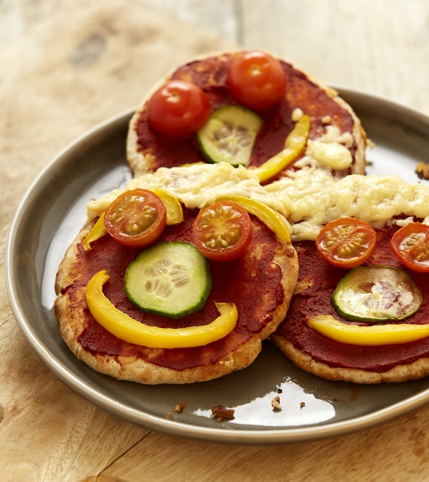

**Pizza Pitta Faces**  
4 wholemeal pitta breads

4 tsp tomato purée

1 tsp dried mixed herbs

8 thin cucumber slices

6 cherry tomatoes, halved

1 yellow or red pepper, deseeded and sliced crossways

40g reduced-fat cheese, grated

1. Preheat the grill or if you prefer, cook these in an oven preheated to 180°C, fan oven 160°C, gas mark 4 for 8-10 minutes.
2. Spread 1 tsp of tomato purée over one side of each pitta bread. Sprinkle with the dried mixed herbs.3
3. Arrange the cucumber and halved tomatoes on the pittas to resemble 'eyes',
4. Halved tomatoes for the 'noses'
5. Sliced pepper to look like 'eyebrows' and 'mouths'
6. Grated cheese for ‘hair’ or ‘beards’.
7. Place on the grill rack and grill for 4-5 minutes.
8. Cool for a few moments, then serve.

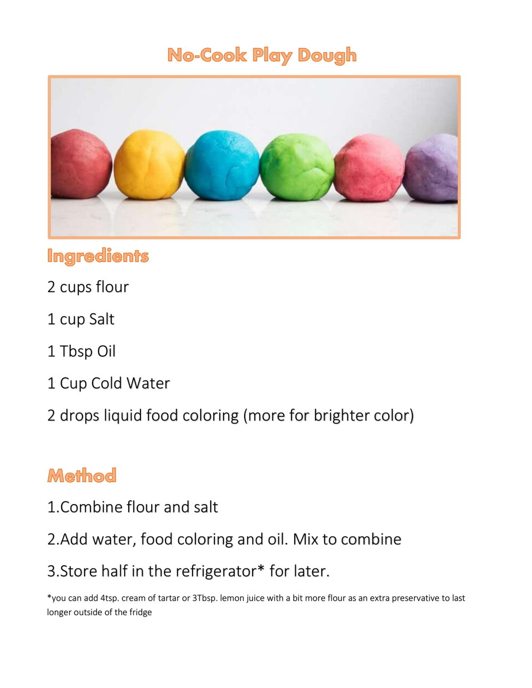

Play Dough Recipes

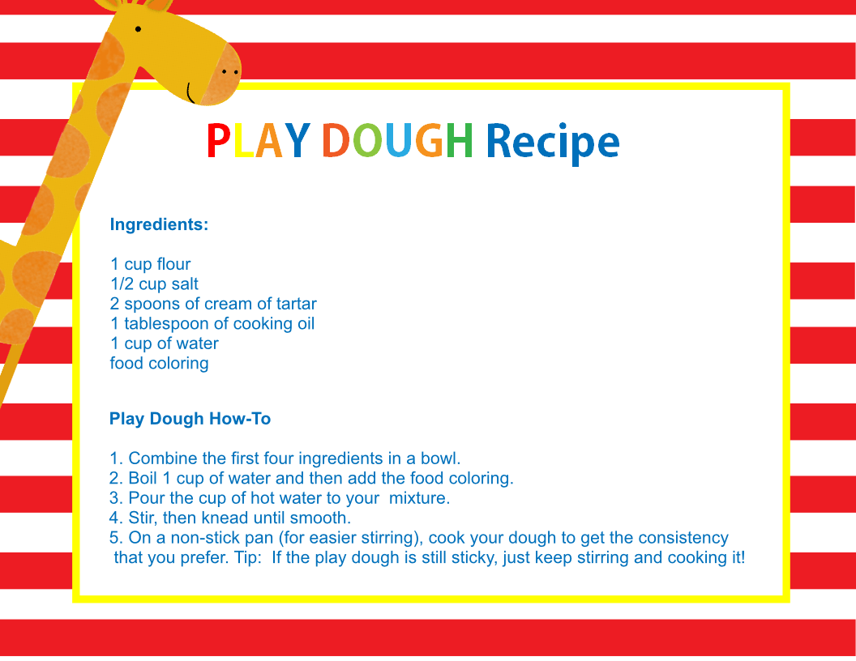

**Craft recipes**

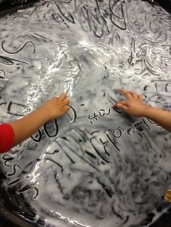

**Edible Paint**

1/2 cup of baby cereal (sometimes called baby rice - easy to find in a supermarket or pharmacy)  
3/4 cup of water  
food colouring (a few drops - depends on the depth of colour you would like - be mindful of clothes being stained if too much used)

Add the ingredients to a food processor or whisk them together if you prefer.

Adjust the water quantity depending on the consistency you would like.

**Cornflour**

2 cups of cornflour

1 cup of water

Food colouring (optional)

Mix all ingredients together

to make a gloopy mixture.

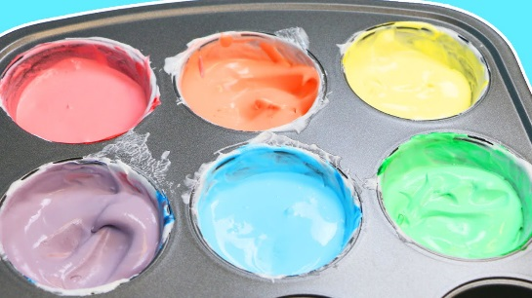

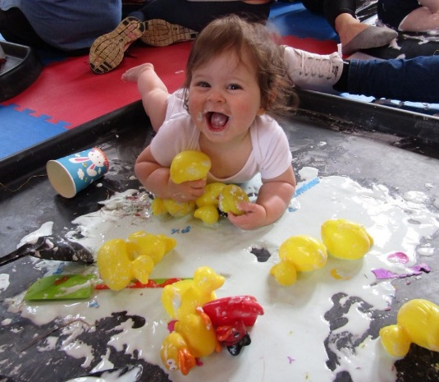

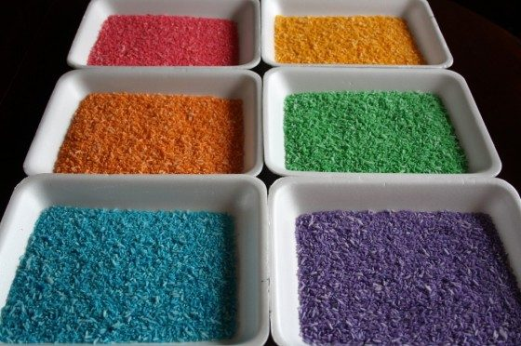

**Coloured Rice**

white rice

Food colouring of choice

Vinegar (optional)

Poor a cup of rice into a cup or container, add a few drops of food colouring and if using a 1/2 teaspoon of vinegar, mix it all together and lay out on a tray or baking sheet to dry.

Store in an airtight container it will last a long time.

**Singing hands songs on you tube—songs with Makaton signing**.

https://www.youtube.com/watch?v=0peZ5AN5vs8&safe=true—The wheels on the bus

https://www.youtube.com/watch?v=yJvEwjK0lSQ&safe=true - Old Macdonald

https://www.youtube.com/watch?v=K2lMJsfoEMw&safe=true - Row row row your boat

https://www.youtube.com/watch?v=mZBZ8J1R_yU&safe=true - 3 little monkeys

**General activities and Parent information**

https://www.bbc.co.uk/bitesize/collections/starting-primary-school/1 - BBC Bitesize—Activities and information for all children. Lots of guidance and advice for parents on a number of common issues including potty training, sleeping etc.

https://www.twinkl.co.uk/resources/parents - Free resources and activities for young children and parent guides.

https://happyhooligans.ca/ - craft activities for toddlers and young children.

**Music and Dance Websites/Links**

https://www.nordoff-robbins.org.uk/news/on-stage-at-home-with-nordoff-robbins-and-the-clangers/

**Reading**

https://www.booktrust.org.uk/ - Reading, singing, activities and games in Book Trust Home Time

https://stories.audible.com/ - In littlest Learners, listen to stories been read aloud.

**Emotional and Wellbeing**

https://en.calameo.com/read/000777721945cfe5bb9cc?authid=Xu9pcOzU3TQx - everybody worries story.

https://www.mentallyhealthyschools.org.uk/resources/ - Resources and activities for Parents and children’s mental wellbeing.

**Physical**

https://www.healthline.com/health/childrens-health/gross-motor-skills - Information of Fine and Gross Motor Skills.

https://www.bbc.co.uk/programmes/b006mvsc - Dancing with Cbeebies presenters.

https://www.nhs.uk/10-minute-shake-up/shake-ups - 10 minute physical games/activities.

Other useful websites

Parent Comments

We’d love to hear how you and your child got on with these activities, so please fill in the form below and either hand into the school office or email it to [enquiry@feathern.bham.sch.uk](mailto:enquiry@feathern.bham.sch.uk).

Alternatively put some photos and comments on Tapestry of your child completing the activities.

How did you find the home learning booklet? Was it easy to use?

Were there any activities/Websites that you particularly enjoyed or found useful?

Was there anything missing or anything you would have liked more information on?

Any other comments?