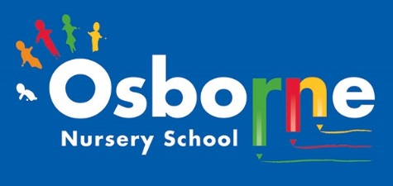**Osborne News**

**February 2022**

Nursery News:

We have welcomed many new families to Nursery this month. The children have settled quickly and are now enjoying lots of different activities. Remember, if you have any questions or need any advice please speak to your child’s key worker.

**Luna New Year:**

We will be learning about different customs and events linked to Lunar New Year. It is the year of the tiger. Tram will be cooking some delicious food for the children to taste! Thank you so much Tram!

The children will be creating their own dragon dances and talking about celebrations that are special to themselves and their families.

What do you celebrate at home with your family?

How do you prepare for special events?

Dates:

Tuesday February 1st 2022: Luna New Year. Celebrations focus in Nursery.

WC: Monday 14th February 2022: Parents Meetings. Information will be sent out via Tapestry.

Monday 21st February – Friday 25th February 2022 : Half Term Holiday-Nursery closed.

Monday 28th February 2022: Nursery is open to children

Thursday March 3rd 2022: World Book Day

**Nursery Reminders:**

**Cold Weather:**

PLEASE remember to send your child to Nursery in a warm coat with a pair of gloves.

**Make sure that all items of clothing are named, including coats!**

**Tapestry:**

Keep up to date with Nursery activities and messages by checking Tapestry regularly.

**Please remember to telephone us on 0121 675 1123 if your child is too ill to be at nursery.** Please keep us updated with any changes of address or phone numbers. Please let the **Elaine or Rebecca** know at our office.

We will continue to implement safety measures at Osborne Nursery:

* **ALL** visitors to wear face coverings in the building, including parents.
* Parents to wear face covering during settling sessions.
* Staff will wear masks in communal areas and continue to use lateral flow tests

( LFT)

* We will reduce the amount of visitors into school
* All classrooms will be well ventilated





This month is **Safer Internet Day.** This day calls upon young people, parents, carers, teachers, social workers, law enforcement, companies, policymakers and wider to join together to make a better internet.

We have achieved the Silver Level of the Rights Respecting Schools Award (RRSA) and as part of this award we work with the children as well as with you to raise awareness about the UN Convention on the Rights of the Child.

**Rights Respecting Schools Award (RRSA)**

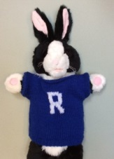

Safeguarding - Keeping children safe on-line

**UN Convention on the rights of the child.**

We will continue to talk to our children about staying safe on line.

We will be sharing the following with the children:

· I will tell an adult when I play on my device

· I will play games that I know

· I can turn on a device and switch off a device

· I know how to stay safe

**Take a look at Cbeebies website – you can find short videos giving advice about making the internet safer. They are also useful for older children in your household too.**

Helping your child at home:

2 year olds

We are learning to look after our bodies ourselves by going to the toilet, washing our own hands, pouring ourselves a drink of water and putting our coats on when it is cold outside.

Please support your child’s attempts at these things at home with lots of praise and encouragement.

3-4 year olds

We will be doing many activities this month around keeping healthy, such healthy eating, brushing our teeth, sleeping and being physically active. You could talk about the foods you eat at home or exercise that they enjoy.

World Book Day:

This year Wold Book Day will be celebrated on March 3rd 2022. We always enjoy new books and stories at Nursery but there will be a big focus on reading during this week. Look out for pictures on Tapestry and extra activities we will be doing. Talk to your child about their favourite story and why they like it. We will be handing out the £1 book tokens during WC 28.02.22.

There are many resources on their website: <https://www.worldbookday.com/share-a-story-corner/>



**We would like to wish all of our families celebrating a very happy LUNA new year!**