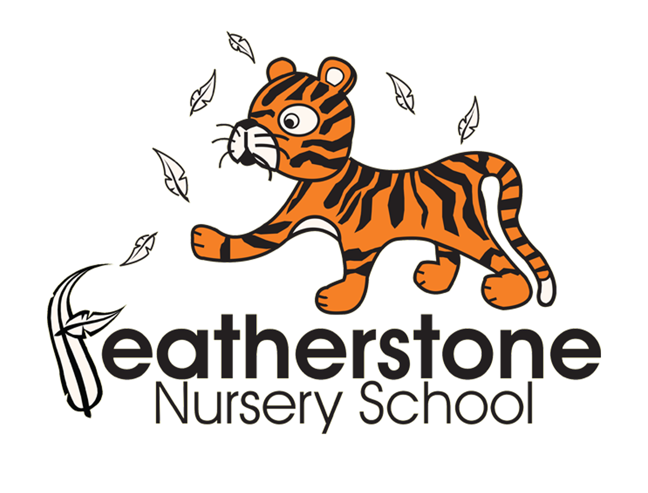
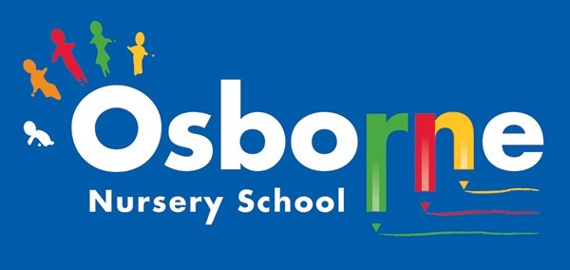

CHARGING & REMISSION POLICY STATEMENT
December 2022

Rationale

The Governing Bodies of both Osborne and Featherstone Nursery Schools recognise the valuable contribution that a wide range of additional activities, including trips, clubs and residential experiences can make towards children’s education and wellbeing.

The Governing Bodies aim to promote and provide such activities both as part of a broad and balanced curriculum for children and as additional optional activities.

Context

The law states that education provided during school hours must be free. This definition includes materials, equipment and transport provided in school hours by the Local Authority or the School. No pupil may be left out of an activity because their parents cannot or will not make a contribution of any kind.

Aims

Our aim is to ensure that access to any relevant activity is available to any child regardless of the parents’ / carers’ ability to pay. Activities will therefore be promoted at no charge or minimal cost.

Charges / Voluntary Contributions

There will however be no obligation for any parent / carer to make a voluntary contribution towards the cost of activities or to the school fund. Pupils will be treated equally whether or not their parent / carer has made a contribution.

General

The Governing Bodies may from time to time, amend the categories of activity for which a charge may be made. Nothing in this policy statement precludes the Governing Bodies from inviting parents to make a voluntary contribution towards the cost of additional activities. If voluntary contributions are not sufficient an activity may be cancelled.

CHARGING & REMISSION POLICY

This policy will be reviewed on a yearly basis and whenever significant changes to the systems and arrangements take place.
Policy Agreed by ………………………... Nursery School Governing Body on ………………
Signed: …………………………………………….. Date : …………………….…………

