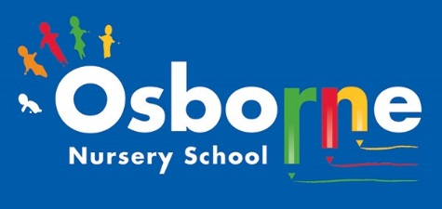**Osborne News**

**July 2023 **

THE WONDERFUL KAREN KINNARD!!

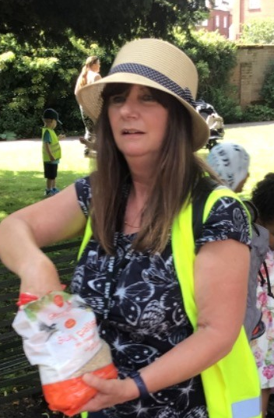

Karen is retiring – she has worked at Osborne Nursery School for over 30 years and taught generations of children. She has provided care and support for many families in our community and given so many children a wonderful start to their academic life. Karen is a much loved member of staff and we will really miss her. We wish her every happiness in her new adventures. Please keep in touch Karen!

Dates for your diary:

Mondays – Stay and Play 9:45am – 11am.

Wednesday 12th July 2023 – Little Learners and 3 year olds to visit Sutton Park

Wednesday 19th July 2023 – Leavers Celebrations – see Tapestry for details

Transition events through July – Please ensure you check emails and letters for visits to your child’s new school.

July 2023 – Visits for new families at Nursery

Friday 30th June – Friday 7th July – Startwell and Transition workshops for each family group. See Tapestry for dates!

Tuesday 25th July 2023 – Last day of the academic year.

Monday 4th and Tuesday 5th September 2022 – NURSERY CLOSED FOR STAFF TRAINING

Monday 30th October 2023 – Friday 3rd November 2023 – HALF TERM

www. osbornenurseryschool.co.uk **0121 675 1123**

Attendance is very important at Nursery. We like to see you for all of your sessions each week. We like families to aim for attendance to be between 95 and 100%. Look out for the Cool Kittens stickers!

Congratulations to Badgers and Caterpillars and Tadpoles in LL PM for the best attendance in Nursery in May. FANTASTIC!! Well done to the parents and carers too. Let’s aim for 95% in July!

Nursery’s trip to Beacon park!

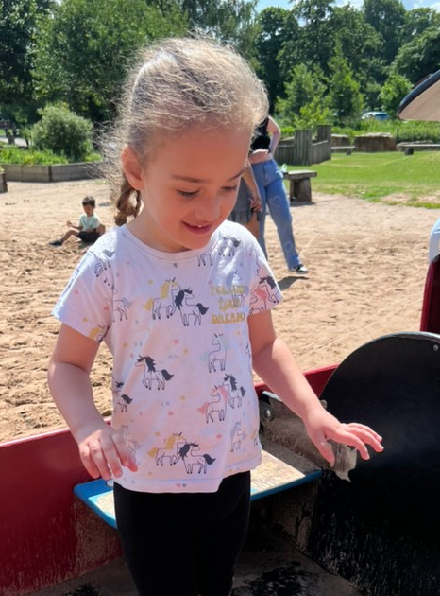 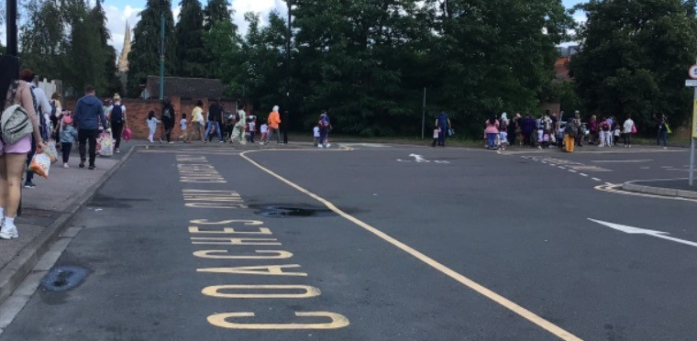

Wow – what a wonderful day! Thank you to all the parents and carers that were able to share the day with us.

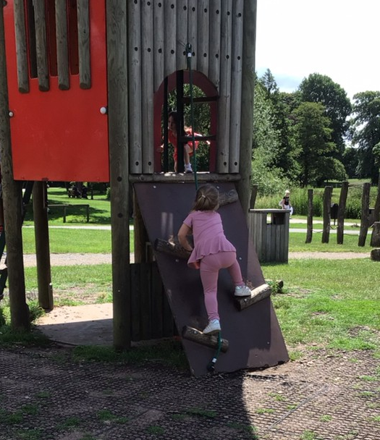 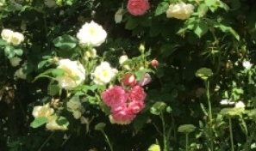



We have achieved the Silver Level of the Rights Respecting Schools Award (RRSA) and as part of this award we work with the children as well as with you to raise awareness about the UN Convention on the Rights of the Child.

July 2nd 2023 is National Thank You Day!

A day to celebrate all the things that keep us connected in our communities, saying ‘thank you’ to each other – making a cup of tea, sharing a cake, lighting up the BBQ, and getting everyone together.

Who can you say thank you today?!

**Rights Respecting Schools Award (RRSA)**

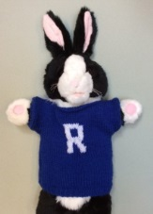

Internet safety: Internet Safety: Over the summer holidays please support your child when they use any devises like IPads or phones. Have a look at the advice below and keep your child safe. **Doing something is better than doing nothing – it is your responsibility**

* Speak to your internet provider if you are unsure. For detailed guidance on the different types of control, you can use this [online tool from Internet Matters](https://www.internetmatters.org/parental-controls/).
* Do not allow any devices in bedrooms – as parents go to sleep, children have a skill at re-awaking.
* Create rules around what’s OK and what’s not.
* Monitor websites and games before allowing children to surf and play freely.
* Ask them to take off headphones so you can listen in.
* Reduce screen time – encourage playing outdoors, sports and develop other interests.
* Talk to your child’s school, make sure academic work is up to date, look at their sleep habits.
* Always let your child know that they should always say if they see or hear anything online that makes them feel scared or uncomfortable and to never arrange to meet someone who they have met online.
* Let them know that they do not have to feel as though they have done something wrong, nobody is going to get cross and it is not their fault.

Children returning to Nursery School in September 2023

Children returning to Nursery School will come back in to school from **Wednesday 6th**

**September.** You will have a letter confirming your child’s pattern of attendance. We look forward to seeing you in September. Please remember to supply nappies and changes of clothes in a named bag.

Thank you.

End of year reports:

Our staff have working hard to write an end of report for every child. This will tell about their successes and areas of development. They will be posted on Tapestry. Please read and comment.

It is great to see the children bringing back their library books every Wednesday – we hope you are enjoying reading at home.

Recommended reading this month: 

Meet Supertato! He's always there for you when the chips are down. He's the supermarket superhero with eyes everywhere - but now there's a pea on the loose. A very, very naughty pea. Has Supertato finally met his match?

These stories have been written by Sue Hendra and Paul Linnet.

Good luck to all of our children that are starting school in September. We have loved having you at our nursery! We look forward to seeing our returning children in September. We will be here ready to support your transition into new groups. We will also be welcoming new children and their families.

We hope you all have an enjoyable summer and remember to stay safe!