**Osborne News**

**June 2023 **

Dates for your diary:

Mondays – Stay and Play 9:45am – 11am.

Drop in session to support families –June 19th 9:30 – 11am . Advice and help for your family, housing, looking after your children and many other areas.

During April and May – working with ‘Learning Through Landscapes Trust’ – workshops.

Monday 29th May – Friday 2nd June 2023 – Half term – nursery closed.

Monday 5th June 2023 – Nursery open

Wednesday21st June 2023 –Older children (Leavers) to visit Lichfield Park with parents.

Wednesday 12th July 2023 – Little Learners and 3 year olds to visit Sutton Park

Wednesday 19th July 2023 – Leavers Celebrations

Tuesday 25th July 2023 – LAST day of term

Nursery News:

The Clay Man!

Andy visited the children in Explorers in May – the work he did with the children was just fantastic!

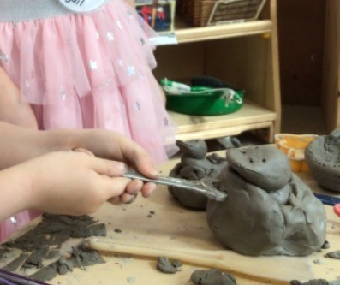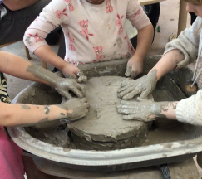

Children learnt new techniques and so many new words. It was a really lovely experience full of learning opportunities. Thank you Andy.

www. osbornenurseryschool.co.uk **0121 675 1123**

**Transition:**

Many of our children will be leaving in July to start their Reception classes in their new schools in September. We are working closely with the schools to ensure that your child’s transition is as smooth as possible. In nursery we will be talking to the children about their new schools, looking at uniform and telling stories about what they could experience. Some teachers will also visit the setting and we will provide reports to inform schools about their achievements.

Here are some top tips for home:

* Talk about their new school – draw pictures or talk about what they will be doing
* Talk about how they are feeling. It’s good to express feelings.
* What changes have they experienced in the past? (New baby, new home?)
* Take a walk past their new school, talk about the route.

Attendance is very important at Nursery. We like to see you for all of your sessions each week. We like families to aim for attendance to be between 95 and 100%. Look out for the Cool Kittens stickers!

Congratulations to SQUIRRELS and CATERPILLARS AM for the best attendance in Nursery in May. FANTASTIC!! Well done to the parents and carers too. Let’s aim for 95% in June!



We have achieved the Silver Level of the Rights Respecting Schools Award (RRSA) and as part of this award we work with the children as well as with you to raise awareness about the UN Convention on the Rights of the Child.

June 20th 2023. World Refugee Day is held on June 20th. This is an annual event, held on the same date each year. World Refugee Day honours the strength and courage of refugees and encourages public awareness and support of the refugees, people who have had to flee their home lands because of conflict or natural disaster.

**Rights Respecting Schools Award (RRSA)**

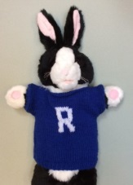

Internet safety: We need to keep our children safe and help them to understand how to play games, use the internet and different devises safely.

A simple and effective way to get involved with your children and their lives online is through discussion. By maintaining an open dialogue with your child and encouraging them to talk to you about their internet use parents can help children access the amazing resources the internet has to offer whilst keeping them safe online.

C:\Program Files (x86)\Microsoft Office\MEDIA\OFFICE14\AutoShap\BD18234_.wmfC:\Program Files (x86)\Microsoft Office\MEDIA\OFFICE14\AutoShap\BD18234_.wmfC:\Program Files (x86)\Microsoft Office\MEDIA\OFFICE14\AutoShap\BD18234_.wmf

It is great to see the children bringing back their library books every Wednesday – we hope you are enjoying reading at home.

Recommended reading this month:

The Snail and The Whale by Julia Donaldson



One tiny snail catches a lift from a gigantic whale. They have all sorts of adventures and see the world. But when the whale is beached – who can save the day?! There are lots of other lovely stories by Julia Donaldson!

Summer Curriculum:

Being Prepared!

The weather is always changing but could we ask you to be prepared?! Have sun cream -ready, named wellies and named and appropriate coats/hats too. Thank you!

Startwell:

Our Little learners have been travelling to school using their scooters and bikes this week – not a pushchair in sight! Well done!

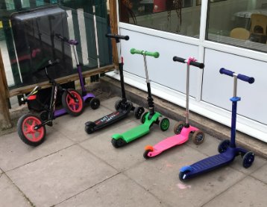  
OFSTED:

Ofsted visited Nursery on Wednesday 10th May. The report is in the process of being written and we will share this with you all as soon as we get it. Thank you to all the parents and carers that took the time to complete the questionnaire or talk to the inspectors.

We hope everyone has enjoyed the half term break and you have managed to get out and about! We look forward to seeing you all on the week beginning 5th June 2023.