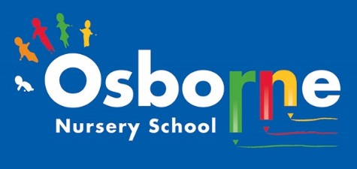**Osborne News**

**October 2023** 

Welcome to the autumn term:

It’s great to see all of the children settling into nursery life, making new friends and getting to know their key workers.

Here are a few reminders for the start of term:

* Remember to keep an eye on Tapestry for updates and photographs
* ALWAYS send spare clothes for your child, named and in a bag
* We provide food and drink – we are a healhty school! You do not need to send in snacks.
* Keep in touch – talk to us and share any exciting news or ask us for advice.

Dates for your diary:

WB: 16th October – Parent/ carer meetings. Look out for dates and times on Tapestry. You will be able to talk to your child’s key worker about the progress they have made.

Every Thursday at Osborne Nursery School - Stay and Play 0-3 year’s old– 9:45 – 11:15am

Monday 30th October – Friday 3rd November 2022 – NURSERY CLOSED HALF TERM.

WB: 13th November: Nursery Rhyme Week – We’ll be learning lots of nursery rhymes during this week, which are great for developing children’s language skills.

WB: 23rd November – Playdough workshops and road safety walks.

Wednesday 29th November: Staff training – NURSERY CLOSED FOR CHILDREN

We love to read!

Watch out for reading bags. We will be helping your child to choose a book each week to read at home with you.

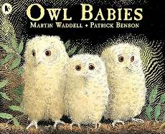

We will posting stories onto Tapestry for your child to watch. You may have already seen Owl Babies read by Liz. Watch out for ‘Dear Zoo’ and ‘So Much’ coming soon.

Cool Kittens at Osborne Nursery.

Attendance is very important at Nursery. We like to see you for all of your sessions each week. We like families to aim for attendance to be between 95% and 100%. Look out for the Cool Kittens stickers

Congratulations to **SQAURES AM** **94%** and **CATERPILLARS PM 91%**for the best attendance in Nursery in September. FANTASTIC!! Well done to the parents and carers.





Article 13 (freedom of expression) Every child must be free to express their thoughts and opinions and to access all kinds of information, as long as it is within the law.

At Nursery we encourage all children to talk and share their opinions. We give children choices and teach them ways to communicate with adults and their friends.

We have achieved the Silver Level of the Rights Respecting Schools Award (RRSA) and as part of this award we work with the children as well as with you to raise awareness about the UN Convention on the Rights of the Child.

**Rights Respecting Schools Award (RRSA)**

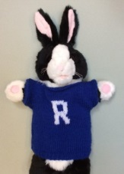

Internet Safety:

Each month we will be looking at using electronic devises safely at home. We need to keep our children safe and help them to understand how to play games, use the internet and different devises safely.

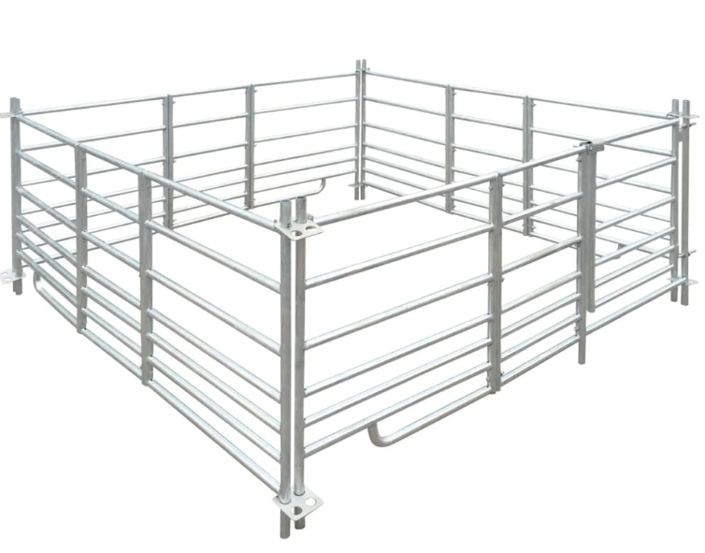

Boundary Fence

* Try to maintain a balance at home – try to encourage your child to have a variety of experiences – not just screen time
* Set parental controls on devises that they use at home
* Try to avoid having devises in the bedroom
* Plan for time away from electronics



Personal details

Please check that details we have for you are correct. Let us know straight away if you have moved house or changed your phone number

Let Sarrina or Rebecca know at our office.

Please remember to telephone our office on **0121 675 1123** or use parent mail/Tapestry if your child is too ill to be at nursery and tell us why they are absent.



The Hidden Nature Challenge.

On Wednesday 4th October we will be taking part in the National Nature Park and Climate Action awards. Our challenge is to take photos of different signs of nature like a raindrop on a leaf or a conker. We will be looking for these signs in unexpected places. You can join in at home too and upload photos onto Tapestry or the website : [www.educationnaturepark.org.uk](https://www.educationnaturepark.org.uk/)

What will you find?!

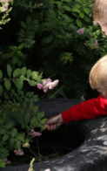

Happy Diwali to all of our families that are celebrating! 