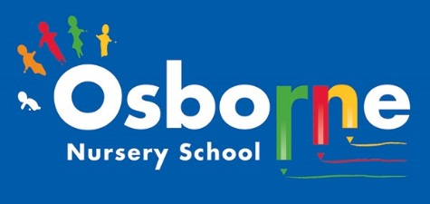**Osborne News**

**December 2024 **

Dates for your diary:

Every Thursday at Osborne Nursery School - Stay and Play with Madi, 0-3 year’s old– 9:45 – 11:15am

Wednesday 6th December – Early Words Together Workshop with Sam – book your slot! Am or pm

WC: 4th December – Wear your favourite bright, wintery or Christmassy jumpers every day!

Wednesday 13th December – Christmas dinner for full time children

Monday 18th December – story time sessions with Little Learners

Wednesday 20th December – Christmas party day! Dress up in your party outfit!

Friday 22nd December – last day of term

Monday 8th January – Nursery closed for children – staff training

Tuesday 9th January 2024 – Nursery open for all children.

Nursery News:

Nursery Rhyme week:

Thank you to all of the parents and carers that were able to join us for activities linking to Nursery Rhyme week! Our staff planned many activities to help your child learn nursery rhymes and to use new vocabulary. Keep singing!!

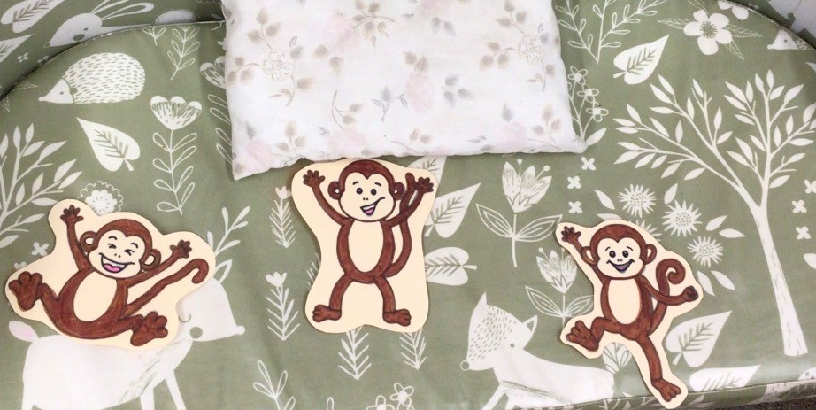

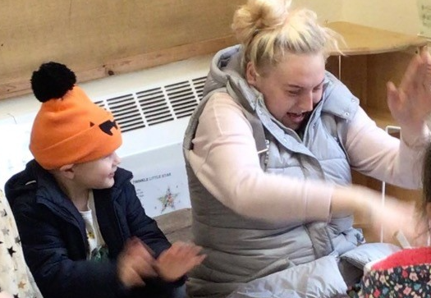

Concept Cat – Julie is leading a new project at Nursery. It is called Concept Cat. Each week the children will be introduced to a new word and we will reinforce the meaning of this word through play and different activities. Make sure that you check Tapestry each week to see the word for the week.

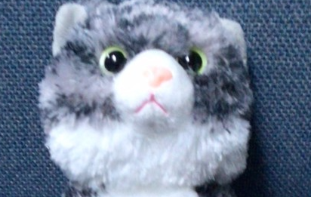

Cool Kittens at Osborne Nursery.

Attendance is very important at Nursery. We like to see you for all of your sessions each week. We like families to aim for attendance to be between 95 and 100%. Look out for the Cool Kittens stickers

Congratulations to Tadpoles AM and Triangles AM for the best attendance in Nursery in November. FANTASTIC! Well done to the parents and carers.





On 10th December 1948, the Universal Declaration of Human Rights was adopted by the United Nations General Assembly. This important moment in human history is now remembered on that date every year and is known as Human Rights Day. All children have the same human rights as adults.

At Nursery we share the rights that children have.

We have achieved the Silver Level of the Rights Respecting Schools Award (RRSA) and as part of this award we work with the children as well as with you to raise awareness about the UN Convention on the Rights of the Child.

**Rights Respecting Schools Award (RRSA)**

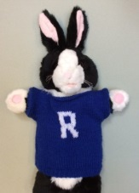

Internet Safety:

Parental controls are the names for a group of settings that put you in control of what content your child can see. Combined with privacy settings, these can help you protect your children from inappropriate content, online grooming, cyberbullying and other [online safety issues](https://www.internetmatters.org/issues/).

When you buy new devices for use at home with the family, make sure that you take time to set up parental controls. We need to keep our children safe – they could be just one click away from viewing something unsuitable.



We love to read!

Norman,The Slug Who Saved Christmas by Sue Hendre and Paul Linnet.

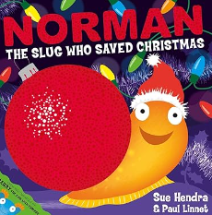This is a fun story to read, can Norman deliver the presents in time? Look out for the story on Tapestry or have a look in your local library.

Reception places at Primary School.

Please ensure you have completed your application for your child’s Reception place for 2022.

The closing date is **15th January 2024**. If you miss this deadline you are less likely to be offered a place at your preferred school. If you need any help or advice please speak to your child’s Key Worker.

Please visit: www.birmingham .gov.uk to apply online for a place. You will also find clear guidance to help.

Personal details

Please remember to telephone our office on **0121 675 1123** or use parent mail/Tapestry if your child is too ill to be at nursery and tell us why they are absent. Let Sarrina or Rebecca know at our office.

Helping Hands Workshops:

Our 3 and 4 year olds have really enjoyed the workshops over the past 5 weeks. They have learnt all about their feelings. Ask your child about the colour monsters – happy, sad, angry, and calm – there is a lovely story to read.



The Staff and Governors hope you all have an enjoyable break and we would like to wish those celebrating, a very happy Christmas.

See you all in 2024!