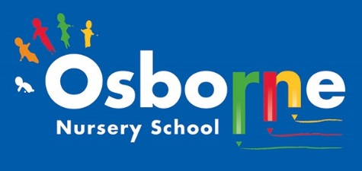**Osborne News**

**November 2023** 

Dates for your diary:

Every Thursday at Osborne Nursery School - Stay and Play with Madi, 0-3 year’s old– 9:45 – 11:15am

Monday 30th October – Friday 3rd November 2022 – NURSERY CLOSED HALF TERM.

WB: 6th November - Firework focus week – Let us stay safe!

WB: 13th November: Nursery Rhyme Week – We will be learning lots of nursery rhymes during this week, which are great for developing children’s language skills. Workshops to be arranged.

Wednesday 22nd November – Academy photos – timings to follow.

Wednesday 29th November: Staff training – NURSERY CLOSED FOR CHILDREN

Wednesday 6th December – Early Words Together Workshop

Friday 22nd December – last day of term

Monday 8th January – Nursery closed for children – staff training

Nursery News:

What a busy half term! Well done to all of our children for settling in so well and making new friends.

Thank you to all of our parents and carers for coming to talk to Key Workers about your child.

Playdough workshops were very popular and we hope you are able to make playdough at home too.

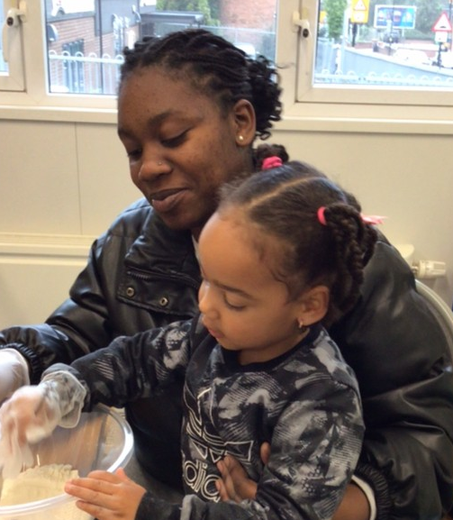

Our local walks for Explorer children were really successful. The children learnt about crossing roads safely and enjoyed looking for numbers and signs.Thank you to all the parents that joined us!

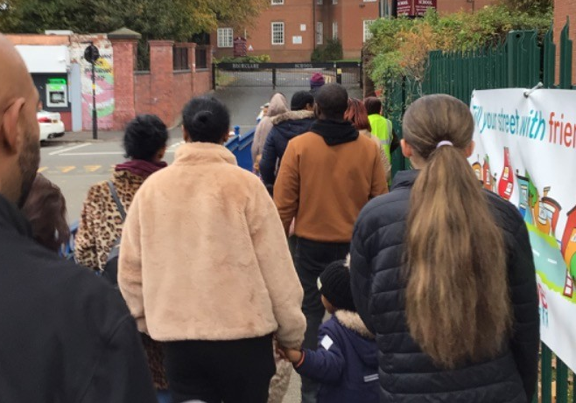

Cool Kittens at Osborne Nursery.

Attendance is very important at Nursery. We like to see you for all of your sessions each week. We like families to aim for attendance to be between 95 and 100%. Look out for the Cool Kittens stickers

Congratulations to Acorns and Triangles for the best attendance in Nursery in October. FANTASTIC!! Well done to the parents and carers.





Every November, we celebrate World Children’s Day, the anniversary of the adoption of the Convention on the Rights of the Child. It’s a global day of action FOR children, by Children. We turn the world blue in support of children’s rights and provide platforms to raise the voices of children and young people on issues they care about.

We have achieved the Silver Level of the Rights Respecting Schools Award (RRSA) and as part of this award we work with the children as well as with you to raise awareness about the UN Convention on the Rights of the Child.

**Rights Respecting Schools Award (RRSA)**

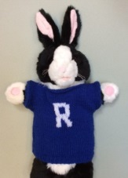

Internet Safety:

Each month we will be looking at using electronic devises safely at home. We need to keep our children safe and help them to understand how to play games, use the internet and different devises safely.

This month’s message is ‘Permanent Marker’

Everything that you put on line is PERMANENT even if you hit the delete button!

Remember to really think about what you share on line about yourself but also your children, family and friends.

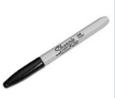

We love to read!

It’s great to see children enjoying looking at books and reading at home. This month’s book is:

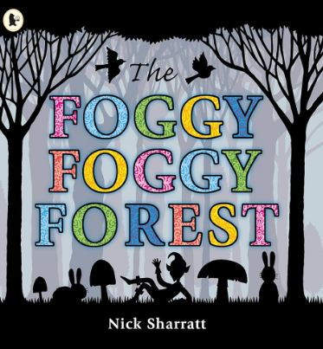

We hope you have been enjoying the stories we have posted onto Tapestry. There are more to come! Remember it is free to visit Birmingham library and they often have free events on for children.

What does my child need to put in their nursery bag?

* A change of clothes - named
* Nappies and wipes
* Spare pants and socks

Please DO NOT bring in:

* Toys
* Sweets
* Any food – we have children with allergies and this could be dangerous.
* No drinks

Personal details

Let Sarrina or Rebecca know at our office.

Please remember to telephone our office on **0121 675 1123** or use parent mail/Tapestry if your child is too ill to be at nursery and tell us why they are absent.

COATS!

Please can you name your child’s coats? Many children have the same coat and size and we need to know which coat belongs to which child!

 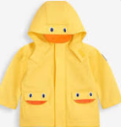  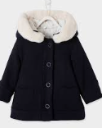 

We know there may be fireworks in our skies for bonfire night make sure you all stay safe and keep pets safe too. Talk about the sounds and sights! <https://www.rospa.com/home-safety/advice/fireworks-safety>